**Set ONE**

**SECTION A**

**1. Give one of the five senses of the body.  
……………………………………………………………………………………………**

**2. What special name is given to the young one of a rabbit?  
……………………………………………………………………………………………**

**3. State one use of proteins in the body.  
……………………………………………………………………………………………**

**4. In the space provided below, draw a well labeled diagram to show that air has weight.**

**5. Name the natural source of heat in the environment.  
……………………………………………………………………………………………**

**6. Why should sick people be given special care?  
……………………………………………………………………………………………**

**7. Of what importance is a lateral line to a fish?  
……………………………………………………………………………………………**

**8. Write any one common example of a communicable disease in our community.  
……………………………………………………………………………………………**

**9. Identify the structure that joins bones to muscles.  
……………………………………………………………………………………………**

**The diagram below shows a simple circuit. Use it to answer questions 10 and 11.**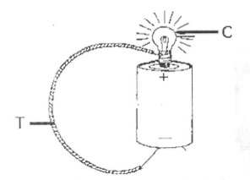

**10. Using arrows, show the direction of flow of the electric current along the wire marked T.**

**11. Apart from light, which other form of energy is produced at C?  
…………………………………………………………………………………………...**

**12. Explain the term “magnetization”.  
…………………………………………………………………………………………...**

**13. Why should you apply grease or oil in moving parts of a machine?  
…………………………………………………………………………………………...**

**14. Of what importance is perspiration on the health of human beings?  
…………………………………………………………………………………………...**

**The diagram below shows a glass of water with a straight ruler in it. Use it to answer question 15.**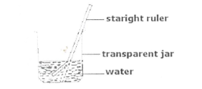

**15. Why does the ruler in the jar above appear bent?  
……………………………………………………………………………………………**

**16. Identify any one structure which helps plants with weak stems to climb other plants.  
……………………………………………………………………………………………**

**17. Name any one ungulate mammal.  
……………………………………………………………………………………………**

**18. Mention one disease that affects both poultry and rabbits.  
……………………………………………………………………………………………**

**19. Write clown any one energy resource from animals,  
……………………………………………………………………………………………**

**20. State any one way by which sound can be stored.  
……………………………………………………………………………………………**

**21.In which part, of the body are lungs found?  
……………………………………………………………………………………………**

**22. Give any one characteristic of an image formed through a pin-hole-camera.  
……………………………………………………………………………………………**

**23. Which part of an insect has a similar function as of stomata on leaves of plants?  
……………………………………………………………………………………………**

**Study the diagram below and use it to answer the questions that follow.**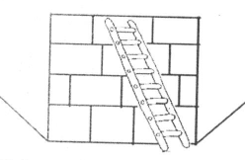

**24. Identify the type of machine drawn above.  
…………………………………………………………………………………………….**

**25. Give one example of a non-biodegradable waste material in our environment.  
……………………………………………………………………………………………**

**26. Write down one disease that affects both the muscles and the bones of the skeletal system.  
……………………………………………………………………………………………**

**27. What name is given to the arrangement of the seven colours that appear when a ray of light is refracted through a triangular prism?  
…………………………………………………………………………………………….**

**28. Give one way methods used in the preservation of fish and millet differ.  
…………………………………………………………………………………………….**

**29. Why is the handle of an flat iron box usually made of wood or plastic?  
…………………………………………………………………………………………….**

**30. Identify any one disease that affects human kidneys.  
…………………………………………………………………………………………….**

**31. Define the term vices in poultry rearing.  
…………………………………………………………………………………………….**

**…………………………………………………………………………………………….**

**Study the diagram and answer the questions that follow.**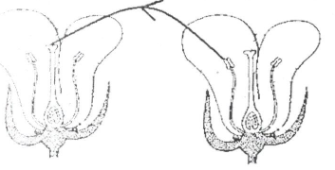

**32. Name the type of pollination shown in the diagram above.  
……………………………………………………………………………………………..**

**33. Monition one measure used by the government of Uganda to fight against the spread of malaria.  
……………………………………………………………………………………………..**

**34. Give one example of anti-social behaviour practiced in your school.  
……………………………………………………………………………………………**

**35. State one way by which friction can be increased.  
……………………………………………………………………………………………**

**36. Why is it advisable for parents to keep drugs out of reach of children?  
……………………………………………………………………………………………**

**37. Francis planted a bean seed and after three days, it germinated, What type of change did the seed undergo?  
……………………………………………………………………………………………..**

**38. Suggest one reason why animals move.  
……………………………………………………………………………………………..**

**39. Mention one function of teeth in food digestion.  
……………………………………………………………………………………………..**

**40. Which type of gas is contained in a fire extinguisher?  
…………………………………………………………………………………………….**

**Section B**

**41(a) Give one example of each of the following:**

**(i) artificial source of light ………………………………………………………………**

**(ii) natural source of light ………………………………………………………………**

**(b) Why is the moon said to be non-luminous object?  
……………………………………………………………………………………………**

**(c) State one way in which reflection is useful to man.  
……………………………………………………………………………………………**

**42(a) Convert 77˚F into the Centigrade scale.  
……………………………………………………………………………………………**

**(b) Give two ways a clinical thermometer is adapted to measuring human body temperature.  
……………………………………………………………………………………………**

**……………………………………………………………………………………………**

**(c) Why doesn’t the scale of the clinical thermometer go beyond 39°C?  
……………………………………………………………………………………………**

**13. The diagram below shows a method of making a magnet. Use it to answer the questions that follow.**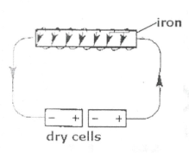

**(a) Name the method of making magnets shown in the diagram.  
……………………………………………………………………………………………**

**b) What would YOU do to the dry cells in order to increase the strength of the magnet?  
……………………………………………………………………………………………**

**(c) Apart from the method shown in the diagram, name any other two methods of making magnets.  
……………………………………………………………………………………………**

**44. Match the diseases with the germs that cause them.  
……………………………………………………………………………………………**

|  |  |
| --- | --- |
| **DISEASE** | **GERM** |
| **Typhus feyer**  **Elephantiasis**  **Malaria**  **Trachoma** | **Plasmodium**  **Bacterium chlamydia**  **Filarial worm**  **Bacterium rickettsia** |

**(a) typhus fever …………………………………………………………………………..**

**(b) elephantiasis ………………………………………………………………………….**

**(c) malaria ………………………………………………………………………………..**

**(d) trachoma …………………………………………………………………………….**

**45(a) Identify any two living components of the environment.  
……………………………………………………………………………………………**

**(b) Mention two ways people depend on each other.**

**…………………………………………………………………………………………….**

**46a) Name the organ that removes urine from the body.  
……………………………………………………………………………………………**

**b) To which body system does the body organ belong?  
……………………………………………………………………………………………**

**c) Where is urine collected before it is removed from the body?  
……………………………………………………………………………………………**

**d) Name one dangerous substance found in urine.  
……………………………………………………………………………………………**

**47 a) What is mulching?  
……………………………………………………………………………………………**

**……………………………………………………………………………………………**

**b) Give two advantages of mulching.  
……………………………………………………………………………………………**

**c) How can mulching be dangerous to a farmer?  
……………………………………………………………………………………………**

**48. The diagram below is of a human tooth. Use it to answer the questions that follow.**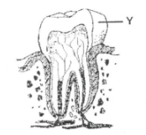

**a) Name part marked Y.  
……………………………………………………………………………………………**

**b) State the function of the part marked Y on the diagram above.  
……………………………………………………………………………………………**

**c)Mention one health problem that can affect human teeth.  
……………………………………………………………………………………………**

**d) Suggest any one way you can care for human teeth.  
……………………………………………………………………………………………**

**49. Use the diagram to answer the questions that follow.**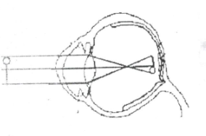

**a) What eye defect is illustrated in the diagram above?  
……………………………………………………………………………………………**

**b) How can the eye defect above be corrected?  
……………………………………………………………………………………………**

**c) Apart from the eye defect illustrated in the diagram, name two other eye defects.  
……………………………………………………………………………………………**

**The diagram below is of a simple machine. Use it to answer the questions that follow.**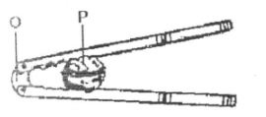

**(a) Name the points of the machine marked O and P.  
……………………………………………………………………………………………**

**(b) To which class of levers does the machine belong?  
……………………………………………………………………………………………**

**(c) Using arrows show the direction of the effort applied when the machine is being used.**

**51(a) Identify two common causes of sickness in a home.  
……………………………………………………………………………………………**

**……………………………………………………………………………………………**

**(h) Write down two ways we can prevent sickness in a home without using drugs.  
……………………………………………………………………………………………**

**52(a) Write STD’s in full.  
……………………………………………………………………………………………**

**b) Suggest any two ways through which a p. 7 candidate can avoid contracting STD’s.  
……………………………………………………………………………………………**

**(c) Apart from having sexual intercourse with an infected person, give any other way of contracting HIV /AIDS.  
……………………………………………………………………………………………**

**53(a) Write AI in full as used in animal reproduction.  
……………………………………………………………………………………………**

**(b) Give one advantage of AI in animal reproduction.  
……………………………………………………………………………………………**

**(c) Define the following terms:**

**(i) gestation period  
……………………………………………………………………………………………**

**(ii) quarantine  
……………………………………………………………………………………………**

**54(a) Name any two ways plants can reproduce.  
……………………………………………………………………………………………**

**(b) Mention the method of propagation used in reproducing the following plants.**

**(i) banana  
……………………………………………………………………………………………**

**(ii) sugarcane**

**……………………………………………………………………………………………**

**55(a) What name is given to the smallest unit of matter that can exist alone with the basic r2perties?  
……………………………………………………………………………………………**

**(b) Give state of matter.  
……………………………………………………………………………………………**

**(c) How does volume of a solid differ from its mass when subjected to different temperatures?**

**……………………………………………………………………………………………**

**(d) Mention one change of state that takes place with heat loss.  
……………………………………………………………………………………………**

**END**

**ITEM TWO**

**SECTION A (40 marks)**

**1. Identify the group of vertebrate that feeds its young one on milk from mammary gland.  
……………………………………………………………………………………………..**

**2. What i capacity?  
……………………………………………………………………………………………..**

**3. Give one difference between plants and animals though they are all living things.  
……………………………………………………………………………………………..**

**4. Write the component of soil that is formed from plant and animal remains.  
……………………………………………………………………………………………..**

**The diagram below sows a type of weather in our environment. Use it to answer questions 5 and 6.**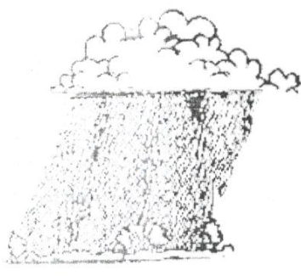

**5. Which condition of weather is shown in above diagram?  
……………………………………………………………………………………………**

**6. How can you protect yourself from the danger of the above type of weather?  
……………………………………………………………………………………………**

**7. State the functional between arteries and veins.  
……………………………………………………………………………………………**

**8. Under what condition would you advise a poultry farmer to carry out culling?  
……………………………………………………………………………………………**

**9. Give one way through which pineapples are propagated.  
……………………………………………………………………………………………**

**10. Mention the property of air that helps a P.6 pupil drink soda from a bottle using a straw.  
……………………………………………………………………………………………**

**11. Apart filtration, name one other method that is used to obtain clear water for washing.  
……………………………………………………………………………………………**

**In the diagram below, normal bean seeds were planted and the conditions shown in the  
experiment. Study the diagram and use it answer questions 12 and 13.**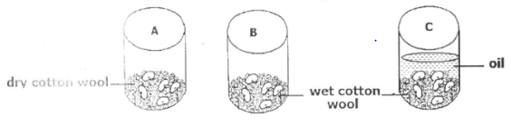

**12. What condition is missing in container A?  
…………………………………………………………………………………………….**

**13. State the role played by cooking oil in container C.  
…………………………………………………………………………………………….**

**14. Define the term “addiction” as used in drugs use.  
…………………………………………………………………………………………….**

**1 5. Name one vaccine that is administered orally.  
…………………………………………………………………………………………….**

**16. Why h it in port u it to carry out mulching in crop growing?  
…………………………………………………………………………………………….**

**17. How is the scap useful when bathing?  
…………………………………………………………………………………………….**

**18. Apart from rain and lakes, state any one natural source of water.  
…………………………………………………………………………………………….**

**19. Give one plant that can he grouped together with Mosses.  
…………………………………………………………………………………………….**

**20. What is soil conservation?  
…………………………………………………………………………………………….**

**The diagram below shows part of the digestive system. Use it to answer questions 21 and 22.**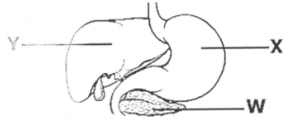

**2 1 . Name the part marked W.  
……………………………………………………………………………………………**

**22. Where is the digestive juice produced at part marked Y stored?  
……………………………………………………………………………………………**

**23. Which sense helps you to identify the colour of a cloth?  
……………………………………………………………………………………………**

**21. Give one advantage of using paddock grazing in livestock management.  
……………………………………………………………………………………………**

**25. How often should one brush teeth?  
……………………………………………………………………………………………**

**The diagram below is of a device driven by one of the resources in our environment. Use it to answer questions 26 and 27.**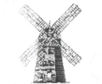

**26. Name the above device.**

**……………………………………………………………………………………………**

**27. State the resource that enables the above device to work.  
……………………………………………………………………………………………**

**28. How is heat different from temperature?  
……………………………………………………………………………………………**

**29. Write down one activity of PHC that helps to promote community hygiene.  
……………………………………………………………………………………………**

**30. Give one malnutritional disease known to you.  
……………………………………………………………………………………………**

**31. What type of change occurs when water changes to ice?  
…………………………………………………………………………………………….**

**32. Identify the product mainly got from Saanen goat.  
…………………………………………………………………………………………….**

**33. Give one example of a person with special needs.  
……………………………………………………………………………………………..**

**34. How is the reproduction of yeast different from that of other fungi?  
……………………………………………………………………………………………..**

**:35. In which body part does respiration take place?  
……………………………………………………………………………………………..**

**36. What is pitch as used in the study of sound?**

**37. Why do we need latrines at school?**

**38. Write 3Ds in full.**

**…………………………………………………………………………………………….**

**39. State on characteristics of arachnids.  
……………………………………………………………………………………………**

**40. Mention the intestinal worm that is prevented through eating fully cooked beef or pork.  
……………………………………………………………………………………………**

**Section B**

**41 (a) What are essential drugs?**

**…………………………………………………………………………………………….  
…………………………………………………………………………………………….**

**(b) Give one example of essential drugs.  
…………………………………………………………………………………………….**

**(c) Mention any one quality of an essential drug.  
…………………………………………………………………………………………….**

**(d) How can essential drugs be a disadvantage to us?  
…………………………………………………………………………………………….**

**42. The diagram shows the movements of a steel strip after being twanged. Use it to answer questions that follow.**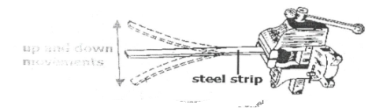

**(a) What term describes the up and down movement of the steel strip after being twanged?  
……………………………………………………………………………………………..**

**(h) How does the sound produced by the steel strip be heard by Peter who is 10 metres away?  
……………………………………………………………………………………………**

**(c) Name one devise that can be used to store the sound produce by the above ruler.  
…………………………………………………………………………………………….**

**(d) How can the volume of the sound produced above be increased?  
……………………………………………………………………………………………..**

**43. Below are the beaks and toes of birds. Use it to answer the questions that follow.**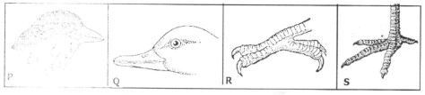

**a) In which environment does the bird with beak Q commonly found?  
……………………………………………………………………………………………..**

**b) What does the bird with foot marked P feed on?  
……………………………………………………………………………………………..**

**c) To which group of birds would you place the bird with beak marked R?  
……………………………………………………………………………………………..**

**d) Give the importance of toes in foot marked S to the birds that have them.  
……………………………………………………………………………………………..**

**44. a) What is air?**

**…………………………………………………………………………………………………………………………………………………………………………………………**

**b) Mention any one component of air known to you.  
……………………………………………………………………………………………**

**c) Which component of air supports the growth of bacteria?  
……………………………………………………………………………………………**

**d) How can air in be a danger our community?  
……………………………………………………………………………………………**

**45 a) Mention the use of the following types of teeth in the human mouth.  
i)Canine…………………………………………………………………………………**

**ii) Incisor……………………………………………………………………..…………**

**b) How are premolars adapted to their function?  
…………………………………………………………………………………………………………………………………………………………………………………………**

**c) In which part of the tooth are the nerves and blood capillaries found?  
……………………………………………………………………………………………**

**46 a) In the space below draw a leaf of a maize plant.**

|  |
| --- |
|  |

**b) Why is a maize plant regarded as an annual crop?  
……………………………………………………………………………………………**

**c) How is a maize plant propagated?**

**……………………………………………………………………………………………**

**d) What is the difference between a maize plant and a fern?  
……………………………………………………………………………………………**

**47. a) Mention any one component of the circulatory system.  
……………………………………………………………………………………………**

**b) Name the pigment in blood on which oxygen is carried.  
……………………………………………………………………………………………**

**c) Why should blood from the heart be pumped to the lungs before circulation to other body parts?  
……………………………………………………………………………………………**

**d) How can t he circulatory system be cared for?  
……………………………………………………………………………………………**

**48 (a) What first aid can you give to the following injuries?**

**(i) burn  
……………………………………………………………………………………………**

**(ii) near drowning  
……………………………………………………………………………………………**

**(b) Identify any one cause of convulsion.  
……………………………………………………………………………………………**

**(c) Give one way of preventing near drowning in our communities.  
……………………………………………………………………………………………**

**49(a) Mention one breed of cattle commonly kept for beef.  
……………………………………………………………………………………………**

**(b) What system of grazing cattle can one use when handling three cows in an urban place?  
……………………………………………………………………………………………**

**(c) Why is pasteurization a better method of preserving milk than sterization?  
……………………………………………………………………………………………**

**(d) Mention any one way of preventing viral diseases in cattle management.  
……………………………………………………………………………………………**

**50(a) What type of soil has the highest capillary?  
……………………………………………………………………………………………**

**(b) State one use of soil to man.  
……………………………………………………………………………………………**

**(c) How can you improve on the fertility of soil without applying artificial fertilizers?  
……………………………………………………………………………………………**

**(d) Give one danger of excessive application of artificial fertilizers.  
……………………………………………………………………………………………**

**51(a) By what process does heat travel through a vacuum?  
……………………………………………………………………………………………**

**(b) State any two effects of heat on matter.  
……………………………………………………………………………………………**

**(c) How is heat energy useful in our daily life?  
……………………………………………………………………………………………**

**52. The diagram below shows one of the system in the human body. Use it to answer questions that follow.**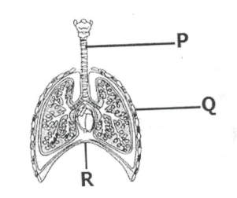

**(a) Name the body system shown in the above diagram.  
……………………………………………………………………………………………**

**(b) Identify part marked Q.  
……………………………………………………………………………………………**

**(c) What happens to part R during breathing in?  
……………………………………………………………………………………………**

**(d) Why is part marked P made of rings of cartilage?  
……………………………………………………………………………………………**

**53(a)Which indicator of a dirty environment is detected by the nose?**

**……………………………………………………………………………………………**

**(b) State the vector that is common n places with poor sanitation.**

**……………………………………………………………………………………………**

**(c) How is the vector in (b) above a danger to human health?**

**……………………………………………………………………………………………**

**(d) Give any one principle of PHC.**

**……………………………………………………………………………………………**

**54. The diagram below shows a burning candle. Use it to answer the questions below.**

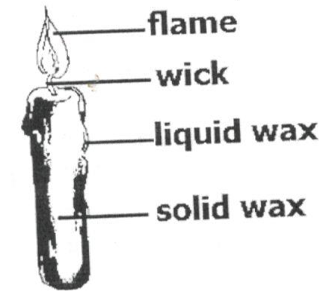

**(a) Give the use of the flame above to man.**

**…………………………………………………………………………………………….**

**(b) What type of change in the environment occurs when;**

**(i) Solid wax melts**

**…………………………………………………………………………………………….**

**(ii) The wick burns**

**…………………………………………………………………………………………….**

**(c) How is the use of candle wax a danger in the environment?**

**…………………………………………………………………………………………….**

**55(a) What is nutrition?**

**…………………………………………………………………………………………….**

**(b) Apart from carbohydrates, which other class of food provide the body with energy?**

**…………………………………………………………………………………………….**

**(c) Identify one food stuff that can provide the body with protein.**

**…………………………………………………………………………………………….**

**(d) Under what condition is one advise to take food rich in iodine?**

**…………………………………………………………………………………………….**

**ITEM THREE**

**SECTION A (40marks)**

**(For questions 1-40 carry one mark each)**

**1. Write AIDS in full.  
……………………………………………………………………………………………**

**2. Give one disadvantage of friction in machines.  
……………………………………………………………………………………………**

**3. Why is the changing of water into ice referred to as a physical change?  
……………………………………………………………………………………………**

**4. State the importance of the blood cell whose shape is drawn below.**

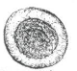 **……………………………………………………………………………………………**

**5Mention one material you would need to prepare Oral Rehydration Solution.  
……………………………………………………………………………………………**

**6. Give one reason why farmers mulch their gardens.  
……………………………………………………………………………………………**

**7. State any one way farmers in Uganda control external cattle parasites.  
……………………………………………………………………………………………**

**8. How is the habit of bees visiting flowers important to plants?  
……………………………………………………………………………………………**

**9. How does refrigeration prevent food stuffs from going bad?  
……………………………………………………………………………………………**

**10. Why does a fish die when removed from water?  
……………………………………………………………………………………………**

**Use the diagram below to answer questions 11 and 12.**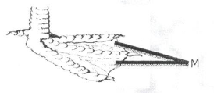

**11. Identify the type of birds with such a type of foot.  
……………………………………………………………………………………………**

**12. How do birds with such type of foot make use of the structure labelled M?  
……………………………………………………………………………………………**

**13. State any one law that governs the taking of alcohol in Uganda.  
……………………………………………………………………………………………**

**14. Mention one animal that uses echoes in its movement.  
……………………………………………………………………………………………**

**15. What is the role of sunlight during photosynthesis?  
……………………………………………………………………………………………**

**16. State one reason why you would prefer artificial insemination to natural insemination in cattle keeping?  
……………………………………………………………………………………………**

**17. Identify one health habit that may result into destruction of the human lungs.  
……………………………………………………………………………………………**

**18. Give any one example of a non-renewable resource in the environment.  
……………………………………………………………………………………………**

**19. What do we call the method of obtaining clean water from muddy water illustrated below?**

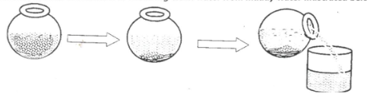 **……………………………………………………………………………………………**

**20. Give one reason why the clean water obtained by the method in No. 19 above is not safe for drinking.**

**……………………………………………………………………………………………  
21. Mention one health problem that may result from over excitement or prolonged hunger.  
……………………………………………………………………………………………  
22. What is the use of a vent pipe found on a VIP latrine?  
……………………………………………………………………………………………**

**23. Identify any one sex offence faced by adolescents.  
……………………………………………………………………………………………**

**24. In one way, give advice to Mrs.Kafeero so as to control the vice of egg eating on her poultry farm.  
……………………………………………………………………………………………**

**25. Identify one danger that may result from sharing a house with potted plants at night.  
……………………………………………………………………………………………**

**26. State one factor that adapts a housefly to spreading germs.  
……………………………………………………………………………………………**

**27. What form of energy would you employ to make water evaporate?  
……………………………………………………………………………………………**

**28. In one way, state how you would help your young sister to promote personal hygiene.  
……………………………………………………………………………………………**

**29. State the reason why a cockroach moves with its abdomen raised on a floor with maize flour.  
……………………………………………………………………………………………**

**30. Why are electricity wires fixed loosely on poles?  
……………………………………………………………………………………………**

**31. Besides using a child health card, how else can you identify a child who was immunised against tuberculosis?  
……………………………………………………………………………………………**

**32. Names one pest that attacks root crops.  
……………………………………………………………………………………………**

**33. State a health problem children may face if underfed with food rich ¡n carbohydrates.  
……………………………………………………………………………………………**

**34. Calculate the density of an object whose mass is 100g and volume 200cc.**

**……………………………………………………………………………………………**

**Use the diagram below to answer the questions 34 and 35.**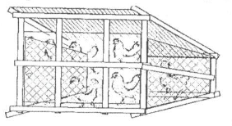

**35. Identify the system of poultry keeping illustrated above.  
……………………………………………………………………………………………**

**36. Give one advantage of the poultry keeping system illustrated above.  
……………………………………………………………………………………………**

**37. Explain one way how blood is prevented from flowing back along vessels during circulation in the human body.  
……………………………………………………………………………………………**

**38. Besides banana fibres, give one example of a plant fibre.  
……………………………………………………………………………………………**

**39. Name the amphibian that lays the eggs drawn below.**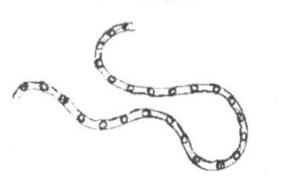

**Ç**

**40. Suggest one way of preventing ourselves from tape worm infections.  
……………………………………………………………………………………………..**

**SECTION B (60 marks)**

**(For questions 41 — 55 carry four marks each)**

**41.a) What is soil erosion?  
……………………………………………………………………………………………..**

**b) Write down one agent of soil erosion.  
……………………………………………………………………………………………..**

**c) Identify any two dangers of soil erosion.  
……………………………………………………………………………………………..**

**42. a) Name the type of metamorphosis a housefly undergoes.  
……………………………………………………………………………………………..**

**b) How is a housefly useful during its larva stage?  
……………………………………………………………………………………………..**

**c) Identify any one disease spread by houseflies.  
……………………………………………………………………………………………..**

**d) Suggest any one way of reducing the spread of diseases by houseflies.  
……………………………………………………………………………………………..**

**43. The diagram below a process in nature. Use it to answer the given questions.**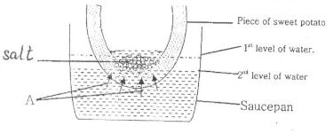

**a) Which process in nature is represented above?  
……………………………………………………………………………………………..**

**b) What do arrows marked A represent?  
……………………………………………………………………………………………..**

**c) Why did the water level in the saucepan reduce after sometime?**

**d) How is the above process useful to plants?  
……………………………………………………………………………………………..**

**44. State one activity a family may do to promote;**

**(i) Family sanitation:  
……………………………………………………………………………………………..**

**ii) Immunisation:  
……………………………………………………………………………………………..**

**iii) Food and Nutrition:  
……………………………………………………………………………………………..**

**iv)Control of communicable diseases.  
……………………………………………………………………………………………..**

**45. The diagram below is of a cross- section an egg. Use it to answer the given questions.**

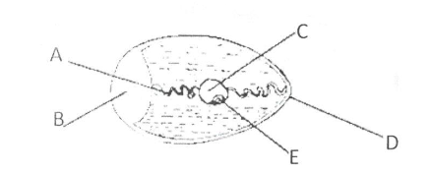

**a) Name the parts labelled C and A.  
……………………………………………………………………………………………**

**b) Apart from protecting the inner parts, give one other function of part D.  
……………………………………………………………………………………………**

**(c) Which letter indicates the part that develops into a chick?  
……………………………………………………………………………………………**

**a) What is environmental degradation?  
……………………………………………………………………………………………**

**b) Outline any two human activities that lead to environmental degradation.  
……………………………………………………………………………………………**

**c) Identify one way by which man helps to allow continued existence of trees.  
……………………………………………………………………………………………**

**46. The diagram below is of a human organ. Use it to answer the given questions.**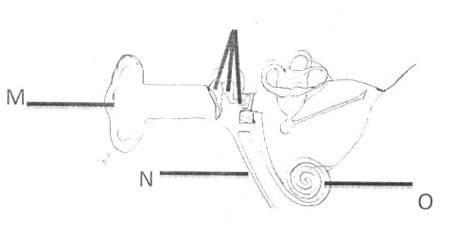

**a) Name the part labelled M.  
……………………………………………………………………………………………**

**b) Give the role of the parts marked O during the hearing process.  
……………………………………………………………………………………………**

**c) Which letter represents the part that equalizes the pressure ¡n the ear to the atmospheric pressure?  
……………………………………………………………………………………………**

**I) Moisture:  
……………………………………………………………………………………………**

**ii) Oxygen:  
……………………………………………………………………………………………**

**52. Match the processes to the gases they need to take place.  
 Process Gas**

**(i) Preservation of bottled drinks: carbon dioxide**

**(ii) Rusting nitrogen**

**(iii) Storage of semen carbon dioxide**

**(iv) Putting out fire oxygen**

**) Preservation of bottled drinks:  
……………………………………………………………………………………………**

**ii) Rusting:  
……………………………………………………………………………………………**

**iii) Storage of semen:  
……………………………………………………………………………………………**

**iv) Putting out fire:  
……………………………………………………………………………………………**

**53.Use the reproductive system below to answer the questions that follow**

**a) Name the part marked P.  
……………………………………………………………………………………………**

**b) What do we call the type of pregnancy where a zygote implants itself in part Q?  
……………………………………………………………………………………………**

**c) What health problem affects part R that women should always checl for?  
……………………………………………………………………………………………**

**d) Which letter indicates the part where sperms are deposited during sexual intercourse?**

**……………………………………………………………………………………………**

**ITEM FOUR**

**SECTION A (40 Marks)**

1. **Which body organ is used for tasting?  
   ……………………………………………………………………………………….**
2. **What does the term vice mean in poultry keeping?  
   ……………………………………………………………………………………….**
3. **How is a seed different from a fruit?  
   ……………………………………………………………………………………….**
4. **Why are metals painted?  
   ……………………………………………………………………………………….**
5. **Mention one characteristic which makes a spider not to be grouped under insects.  
   ……………………………………………………………………………………….**
6. **Why do people preserve food?  
   ……………………………………………………………………………………….**
7. **How are conifers different from other non-flowering plants?  
   ……………………………………………………………………………………….**
8. **What property of air does the diagram illustrate?**
9. 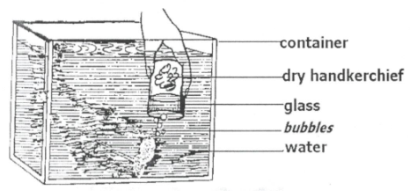 **……………………………………………………………………………………….**
10. **Give the function of a pinna in a human ear.  
    ……………………………………………………………………………………….**
11. **Explain how plants are used as energy resources in our environment.  
    ……………………………………………………………………………………….**
12. **Name the type of change that takes place when mangoes ripen.  
    ……………………………………………………………………………………….**
13. **Why does a needle placed gently on the surface of water float?  
    ……………………………………………………………………………………….**
14. **What is the importance transpiration to plants?  
    ……………………………………………………………………………………….**
15. **What component of loam soil makes it most suitable for growing crops?  
    ……………………………………………………………………………………….**
16. **State the importance of grit in the digestive system of a bird.  
    ……………………………………………………………………………………….**
17. **Identify one example of a magnetic substance.  
    ……………………………………………………………………………………….**
18. **Smoking is very bad to human health. Why does the government of Uganda licence companies that make cigarettes?  
    ……………………………………………………………………………………….**
19. **Write CDD in full.  
    ……………………………………………………………………………………….**
20. **Why are people encouraged to drink boiled water?  
    ……………………………………………………………………………………….**
21. **A female fish lays eggs in water. How are these eggs fertilized?  
    ……………………………………………………………………………………….**
22. **Nanku burnt herself with a hot flat iron. What type of injury did she get?  
    ……………………………………………………………………………………….**

**Use the diagram below to answer question 22.**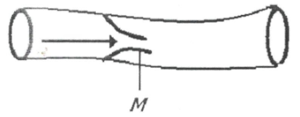

1. **What is the importance of the structure marked M in the above blood vessel?  
   ……………………………………………………………………………………….**
2. **Give one difference between a sprain and a strain**.  
   **……………………………………………………………………………………….**
3. **In which part of a human body are red blood cells made?**

**……………………………………………………………………………………….**

1. **Identify the body part an insect uses for balancing during flight.  
   ……………………………………………………………………………………….**
2. **What does the term “resource” mean?  
   ……………………………………………………………………………………….**
3. **Why do we see the flash of lightning before we hear the sound of thunder during rain storms?  
   ……………………………………………………………………………………….**
4. **Write down the vector that spreads elephantiasis.  
   ……………………………………………………………………………………….**
5. **Convert 100°C to °F.  
   ……………………………………………………………………………………….**
6. **What eye defect is shown in the diagram below?**

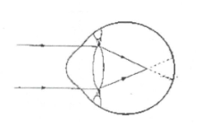 **……………………………………………………………………………………….**

1. **Why is the measles vaccine administered at the age of nine months?  
   ……………………………………………………………………………………….**
2. **State one advantage of family planning.  
   ……………………………………………………………………………………….**
3. **Identify one psychological characteristic which is common in adolescents.  
   ……………………………………………………………………………………….**
4. **Apart from getting sunlight, why else do weak stems climb others  
   ……………………………………………………………………………………….**
5. **How does rural electrification help in conserving the environment?  
   ……………………………………………………………………………………….**
6. **Name one cold blooded vertebrate that has a bony shell.  
   ……………………………………………………………………………………….**
7. **Identify one health reason why building industries should be limited.  
   ……………………………………………………………………………………….**
8. **Why should wood being burnt into charcoal be covered with soil?  
   ……………………………………………………………………………………….**
9. **In the space provided below, draw a compound pinnate leaf.  
   ……………………………………………………………………………………….**
10. **Why is food digestion said to begin in the mouth?  
    ……………………………………………………………………………………….**

**SECTION B**

1. **(a) What is a solute?.  
   ……………………………………………………………………………………….**

**(b) Give one solute used in making ORS.  
……………………………………………………………………………………….**

**(c) Why is water said to be a universal solvent?**

**……………………………………………………………………………………….**

**(d) What health condition can be treated using ORS?**

**……………………………………………………………………………………**

1. **The diagram below shows an electric circuit. Study it carefully and answer the questions about it.**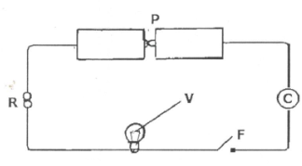
2. **Name part marked F.  
   ……………………………………………………………………………………….**
3. **Give the function of part marked R.  
   ……………………………………………………………………………………….**
4. **What form of energy is contained ¡n part marked P?  
   ……………………………………………………………………………………….**
5. **Why should part marked V fail to produce light when F ¡s closed?  
   ………………………………………………………………………………………**
6. **Study the diagram and answer the questions about it**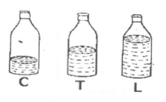
7. **Which of the bottles, when air is blown into them, will produce sound of the highest pitch?  
   ……………………………………………………………………………………**
8. **Give a reason for your answer in (a) above.  
   ………………………………………………………………………………….**
9. **How can you make the bottles to produce the same sound pitch of sound?  
   ……………………………………………………………………………………**
10. **What does the term “volume of Sound” mean?  
    …………………………………………………………………………………..**
11. **(a) Give one example of a legume.  
    ………………………………………………………………………………………**

**(b) How are nitrates important to leguminous plants?**

**……………………………………………………………………………………**

**(c) What food value do we get from leguminous plants?**

**……………………………………………………………………………………**

**(d) Apart from root nodules, given any other characteristic of leguminous plants.  
………………………………………………………………………………………**

1. **The diagram shows a burning candle. Use it to answer the questions about it.**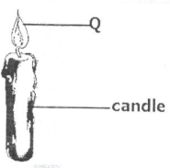
2. **Name two forms of energy given off at Q.  
   ………………………………………………………………………………………**
3. **Which component of air supports the candle to burn?  
   ………………………………………………………………………………………**
4. **Identify one other process in living things that uses the same gas as in the experiment above.  
   ………………………………………………………………………………………**
5. **(a) Identify one type of cattle kept in Uganda.  
   ………………………………………………………………………………………**

**(b) Give the importance of the type of cattle you have named in (a) above.  
………………………………………………………………………………………**

**(c) Identity two advantages of rearing exotic breeds of cattle over local breeds of cattle.  
………………………………………………………………………………………**

1. **(a) Define the following terms:**
2. **Temperature**

**………………………………………………………………………………………**

1. **Boiling point**

**………………………………………………………………………………………**

1. **Heat**

**………………………………………………………………………………………**

1. **Evaporation**

**………………………………………………………………………………………**

1. **The diagram below shows a light ray being reflected through a plane mirror.**

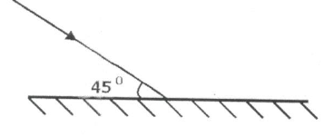

1. **Complete the diagram above.**

**………………………………………………………………………………………**

1. **Calculate the value of the angle of reflection.**

**………………………………………………………………………………………**

1. **What type of reflection is shown in the diagram?**

**………………………………………………………………………………………**

1. **Give one characteristic of images formed through a plane mirror.**

**………………………………………………………………………………………**

1. **(a)What is Primary Health Care?**

**………………………………………………………………………………………**

**(b)Give two elements of Primary Health Care.  
 ……………………………………………………………………………………**

**(c)State one activity done by a community in order to promote primary Health Care.**

**……………………………………………………………………………………**

1. **(a)Write AIDS in full.  
   ………………………………………………………………………………………**

**(b)Write down two ways through which AIDS s spread.  
 ………………………………………………………………………………………**

**(c)What is the best way for a P. 7 pupil to avoid contracting AIDS?  
 ………………………………………………………………………………………**

1. **Study the diagram below and answer the questions about**

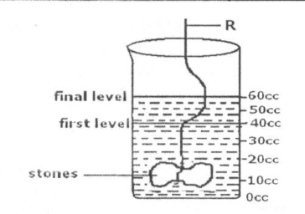

1. **Find the volume of the stone.**

**………………………………………………………………………………………….**

1. **Give the use of the use of R in the experiment.**

**………………………………………………………………………………………….**

1. **Why do objects weigh less in water than in air?**

**………………………………………………………………………………………….**

1. **Name the method used to find the volume of the stone.**

**………………………………………………………………………………………….**

1. **Study the diagram of the kidney and answer the questions that follow.**

**(a)Name the parts marked H and D.**

**………………………………………………………………………………………….**

**(b)Which type of blood is carried by blood vessel marked B?**

**………………………………………………………………………………………….**

**(c)Give one disease thai affects the organ in the diagram above.**

**………………………………………………………………………………………….**

1. **(a)What is a food chain?**

**……………………………………………………………………………………….**

**(b)Differentiate between primary consumers and secondary consumers.**

**……………………………………………………………………………………….**

**(c)Give two ways how plants depend on each other.**

**……………………………………………………………………………………….**

1. **The diagram below shows a clinical thermometer use it to answer the questions that follow.**

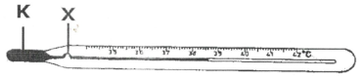

1. **What is the use of the above instrument?**

**……………………………………………………………………………………**

1. **Name liquid marked K.  
   ……………………………………………………………………………………**
2. **In a human heart, which part carries out a similar function as part marked X?  
   ……………………………………………………………………………………**
3. **Give the importance of part marked X.**

**……………………………………………………………………………………**

1. **Study the diagram below answer the questions that follow.**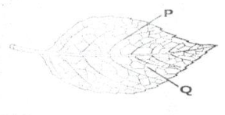

1. **Name part marked P.  
   ……………………………………………………………………………………**
2. **What important practice in part marked Q?  
   ……………………………………………………………………………………**
3. **Give two raw material process named in (b) above to take place.  
   ……………………………………………………………………………………**

**……………………………………………………………………………………**

**END**

**ITEM FIVE**

**SECTION A:**

**1. Name the human organ for tasting.  
………………………………………………………………………**

**2. Why is brushing teeth a good health practice?  
………………………………………………………………………**

**3. Write down one activity a tarn ‘r can do ¡n the dry season.  
………………………………………………………………………**

**4. How does bush burning cause soil erosion?  
………………………………………………………………………**

**5. State any one danger of defecating in the bush.  
………………………………………………………………………**

**6. In one sentence, state how heat promotes food hygiene.  
………………………………………………………………………**

**7. Give any activity done to protect cattle from ecto parasites.  
………………………………………………………………………**

**8. How is the function a fuse similar to a switch in an electric circuit?  
………………………………………………………………………**

**9. In one word, write name given to animals without backbones.  
………………………………………………………………………**

**The diagram below is of a simple machine. Use it to answer questions l0 and 11.**

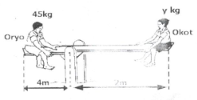

**10. Use letter “F” to show the position of the fulcrum.  
………………………………………………………………………**

**11. Which class of levers is the above machine?  
………………………………………………………………………**

**12. In what way is a human kidney and the skin similar in function?  
………………………………………………………………………**

**13. Why is soil erosion considered as a physical change?  
………………………………………………………………………**

**14. Name the type of digestion in which the teeth breaks down food into small particles.  
………………………………………………………………………**

**15. How do plants reduce the amount of carbon dioxide in the atmosphere?  
………………………………………………………………………**

**16. Give the type of electricity produced when a plastic pen is rubbed on the hair.  
………………………………………………………………………**

**17. In one sentence, write the difference between lung cancer and other respiratory diseases.  
………………………………………………………………………**

**18. How do germs that cause AIDS affect the immune system of the body?  
………………………………………………………………………**

**19. Name the part of attracts pollinators.  
………………………………………………………………………**

**The diagram below is o human arm. Use it to answer question 20.**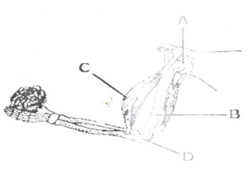

**20. Why is the joint A able to turn in all directions?  
……………………………………………………………………….**

**21. What type of energy is possessed by a radio placed in a moving car?  
……………………………………………………………………….**

**22. Why does class soil retain water longer than sandy soil?  
……………………………………………………………………….**

**23. In the space below draw and label prop roots.**

**……………………………………………………………………….**

**24. How can a farmer make use of cow dung to control deforestation?  
……………………………………………………………………….**

**25. Name the non-living resource which supports life of a tilapia.  
……………………………………………………………………….**

**26. Why should garden tools be cleaned every after use?  
……………………………………………………………………….**

**27. Name the part of the body where respiration takes place.  
……………………………………………………………………….**

**28. Mention one way a magnet can lose its magnetism.  
……………………………………………………………………….**

**29. Why do motorcyclists wear helmets?  
……………………………………………………………………….**

**30. Name any one plant that stores its food in the stem.  
……………………………………………………………………….**

**31. Give one factor that determines the size of an image in a pin hole camera.  
……………………………………………………………………….**

**32. Which component of air is a bi-product of photosynthesis?  
……………………………………………………………………….**

**The diagram below is of a simple complete electric circuit. Use it to answer question 33.**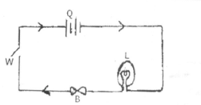

**33. Name the form of energy which takes place at point L when the circuit is completed.  
………………………………………………………………………………**

**34. Which health measures can be done to a latrine which smells and is full of flies?  
………………………………………………………………………………**

**35. Give one way in which fruits are good in prevention of deficiency disease.  
………………………………………………………………………………**

**36. When it is said that Isaac is anemic. What mineral is he lacking in his blood?  
………………………………………………………………………………**

**37. How can the School Health Committee tell whether a child is already immunized against measles without referring to the Child-Health Card?  
………………………………………………………………………………**

**38. Mention one danger of sharing a drug with another patient.  
………………………………………………………………………………**

**39. Apart from controlling erosion, give one other reason why mulching is important.  
………………………………………………………………………………**

**40. Name the major way through which AIDS virus ¡s spread.  
………………………………………………………………………………**

**SECTION B**

**41a). Name the vaccine used to immunize against tuberculosis.  
………………………………………………………………………………**

**b). Give the immunization site for whooping cough.  
………………………………………………………………………………**

**c). Why is immunization an important health activity among children?  
………………………………………………………………………………**

**d). Apart from immunization, state any other way children’s immunity is boosted.  
………………………………………………………………………………**

**42, The list below shows two groups of vertebrates shown above.  
A B**

**Chameleon toads**

**Lizard frog**

**Snake newt**

**Crocodile salamander**

**a). Identify the groups of vertebrates shown above.  
A………………………………………………………………………………**

**B………………………………………………………………………………**

**b). How is reproduction of animals n group A different from those in group B?  
………………………………………………………………………………**

**c). State any one use of scale on a fish.  
………………………………………………………………………………**

**43a). Give the meaning of the following words as used in the study of sound.**

**i) pitch.  
………………………………………………………………………………**

**ii. frequency  
………………………………………………………………………………**

**¡ii. volume  
………………………………………………………………………………**

**b). How does a guitar produce sound?  
………………………………………………………………………………**

**44a). How do organisms such as mushrooms reproduce?  
………………………………………………………………………………**

**b). Give one similarity between a bacteria and fungi.  
………………………………………………………………………………**

**c). Give two examples of fungi apart from mushrooms.  
………………………………………………………………………………**

**45a). Give any two methods of making alcohol.  
………………………………………………………………………………**

**………………………………………………………………………………**

**b). State any one scientific value of alcohol in the society.  
………………………………………………………………………………**

**c). Give any one health effect of alcohol to an individual,  
………………………………………………………………………………**

**46. The diagram below shows an object Y placed ¡n front of a plane mirror M. Use it to answer the questions that follow.**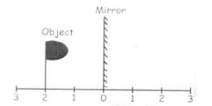

**:**

**(a) Draw on the diagram above the image of the object P.  
………………………………………………………………………………**

**(b) Give any two characteristics of images formed in such mirrors mentioned above.  
………………………………………………………………………………**

**(c) State any one use of side mirrors to motorists.  
………………………………………………………………………………**

**47a). Give any one other state of matter apart from liquid.  
………………………………………………………………………………**

**b). Give two reasons why we give first aid to casualties.  
………………………………………………………………………………**

**c). How is a burn different from a scald?  
………………………………………………………………………………**

**d). Give one major cause of fainting.  
………………………………………………………………………………**

**8. The table below is about nutrition. Use it to answer question 48.**

|  |  |  |
| --- | --- | --- |
| **FOOD VALUE** | **SOURCE** | **DEFICIENCY DESEASE** |
| **…………………** | **Fish** | **Kwashiorkor** |
| **Vitamin A** | **Green vegetables** | **………………………..** |
| **Carbohydrates** | **…………………** | **Marasmus** |
| **…………………** | **Oranges, guavas** | **Scurvy** |

**49. The diagram below is of a female reproductive organ in man. Use it to answer questions.**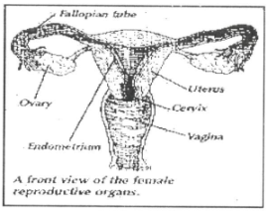

**a). Name the parts labelled;  
X_____________________________ Y _____________________________**

**b). Give the function of part labeled X.  
………………………………………………………………………………..**

**c). Name the part shown above where fertilisation takes place.  
………………………………………………………………………………**

**50a). Give any two disease vectors whose life cycle passes through water.  
………………………………………………………………………………**

**b). State nay diseases caused by poor sanitation in an area.  
………………………………………………………………………………**

**51. (a) Lightning can destroy buildings, give any other two dangers of lightening.  
………………………………………………………………………………**

**(b) Give any other two ways in which people can protect themselves from dangers of lighting,  
………………………………………………………………………………**

**52a). Which germ causes AIDS?  
………………………………………………………………………………**

**(b)Why is abstinence considered the best method for controlling AIDS among youth?  
………………………………………………………………………………**

**(c)Apart from AIDS, give two other sexually transmitted diseases.  
………………………………………………………………………………**

**53. (a)Name the type of blood found in the following blood vessels.**

**(i) Vena cava   
………………………………………………………………………………**

**(ii). Pulmonary vein  
………………………………………………………………………………**

**(b)How are valves useful n a human heart?  
………………………………………………………………………………**

**(c)Name the component of blood that carries oxygen around the body.  
………………………………………………………………………………**

**54. Give the use of the following instruments as a it used at the weather station.**

1. **Anemometer  
   ………………………………………………………………………………**
2. **Rain gauge  
   ………………………………………………………………………………**
3. **Wind sock  
   ………………………………………………………………………………**
4. **Hygrometer   
   ………………………………………………………………………………**

**55.(a)Mention any two agents of seed dispersal.  
………………………………………………………………………………**

**………………………………………………………………………………**

**(b)How is dispersal of seeds important?.  
………………………………………………………………………………**

**………………………………………………………………………………**

**(c)How are fruits such as passion fruits adapted to the way ¡n which  
………………………………………………………………………………**

**………………………………………………………………………………**

**END**

**ITEM SIX**

**SECTION A:**

**1. Which body part of a cow is attacked by a disease detected by using a strip cup?  
……………………………………………………………………………………………**

**2. Name the organisms found in root nodules.  
……………………………………………………………………………………………**

**3. What type of germination do cereals undergo?  
……………………………………………………………………………………………**

**4. Give one use of trees around a home.  
……………………………………………………………………………………………**

**5. Calculate the effort needed to raise a load of 25Kg. using the machine shown below.**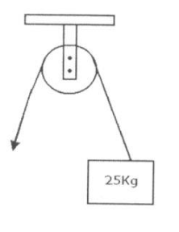

**6. Calculate the electrical force produced by 4 ordinary dry cells.  
……………………………………………………………………………………………**

**7. Give the importance of webbed feet to a duck.  
……………………………………………………………………………………………**

**8. What is obtained by mixing a solvent with a solute?  
……………………………………………………………………………………………**

**9. Name the organ which controls the central nervous system.  
……………………………………………………………………………………………**

**10. What condition leads to goiter?  
……………………………………………………………………………………………**

**11. What is common about the blood carried by the venacava and the pulmonary vein?  
……………………………………………………………………………………………**

**12. How are seeds of a blackjack dispersed?  
……………………………………………………………………………………………**

**13. How do ferns differ from mushrooms?  
……………………………………………………………………………………………**

**14, What is the function of saliva in food digestion?  
……………………………………………………………………………………………**

**15. State the use of a fuse in an electric circuit.  
……………………………………………………………………………………………**

**16. How is heat transfer by radiation different from heat transfer by conduction?  
……………………………………………………………………………………………**

**17. Where in the body of a mammal does conception take place?  
……………………………………………………………………………………………**

**18. Why are roughages important in food digestion?  
……………………………………………………………………………………………**

**19. State one effect of motor accidents on people’s health.  
……………………………………………………………………………………………**

**20. How does overgrazing lead to soil erosion?  
……………………………………………………………………………………………**

**21. Write HIV in full.  
……………………………………………………………………………………………**

**22. Why is a vulture an important bird in the environment?  
……………………………………………………………………………………………**

**23. Apart from lungs and kidneys, name one other excretory organ of a human body.  
……………………………………………………………………………………………**

**24. What is the importance of chlorophyll during photosynthesis?  
……………………………………………………………………………………………**

**25. Which disease is characterized by loss of feeling in the body?  
……………………………………………………………………………………………**

**Use the diagram below to answer questions 26 and 27.**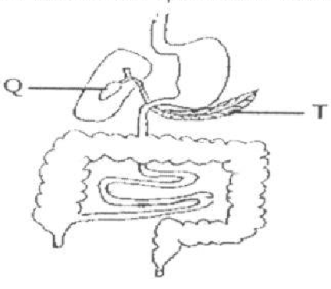

**26. What is the function of the liquid stored in part marked Q?  
……………………………………………………………………………………………**

**27. Name the digestive juice produced by part T.  
……………………………………………………………………………………………**

**28. What causes fainting?  
……………………………………………………………………………………………**

**29. Give one reason why water is used in preparing oral rehydration solution.  
……………………………………………………………………………………………**

**30. Why is immunization in Uganda given to children freely?  
……………………………………………………………………………………………**

**31. Why is water not a good material in extinguishing petrol fires?  
……………………………………………………………………………………………**

**32. State one way of avoiding hookworm infection.  
……………………………………………………………………………………………**

**33. What change does soft undergo when it dissolves in water?  
……………………………………………………………………………………………**

**34. State the primary sex characteristic that takes place only in male adolescents.  
……………………………………………………………………………………………**

**Use the diagram below answer questions 35 and 36.**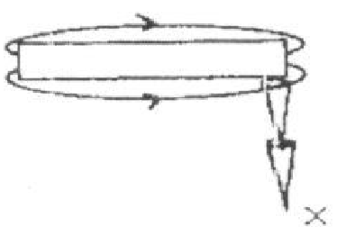

**35. What method of magnetization is illustrated above?  
……………………………………………………………………………………………**

**36. What pole will X be?  
……………………………………………………………………………………………**

**37. At what stage of growth is a frog similar to a flsh in terns of breathing?  
……………………………………………………………………………………………**

**38. What do you understand by the term arson?  
……………………………………………………………………………………………**

**39. Explain how a shadow is formed.  
……………………………………………………………………………………………**

**40. Name one pest that destroys maize plants.  
……………………………………………………………………………………………**

**Section B**

**41. Use the diagram below to answer the questions that follow.**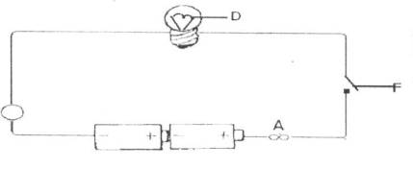

**(a) What is the function of the following in the electric circuit?**

**(I) part A:  
……………………………………………………………………………………………**

**(ii) Part F:  
……………………………………………………………………………………………**

**(b) Name the mineral from which part D is made.  
……………………………………………………………………………………………**

**(c) Give the energy change that takes place at D when the circuit is closed.  
……………………………………………………………………………………………**

**12(a) Name two diseases immunized against at birth.  
……………………………………………………………………………………………**

**(b) State one use of a child health child to mothers.  
……………………………………………………………………………………………**

**(c) State one reason why measles ¡s immunized against at the age of 9 months.  
……………………………………………………………………………………………**

**43(a) Give one reason why people take alcohol.  
……………………………………………………………………………………………**

**(b) Give one method used in preparing alcohol.  
……………………………………………………………………………………………**

**(c) State one body organ affected by excess taking of alcohol.  
……………………………………………………………………………………………**

**(d) Mention one danger of alcoholism to.a family.  
……………………………………………………………………………………………**

**44(a) What is a balanced diet?  
……………………………………………………………………………………………**

**(b) What class of food is best for growth and repair of worn out parts of the body?  
……………………………………………………………………………………………**

**(c) What is the best food for babies?  
……………………………………………………………………………………………**

**(d) State one reason why bottle-feeding is highly discouraged.  
……………………………………………………………………………………………**

**45 The diagram below a brick being lowered in a cylinder containing water.**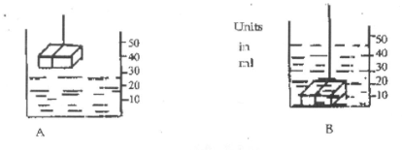

**(a) What is the volume of the brick?  
……………………………………………………………………………………………**

**(b) If the mass of the brick is 60g, calculate its density.  
……………………………………………………………………………………………**

**(c) Why does the brick sink ¡n water?  
……………………………………………………………………………………………**

**(d) Why do objects weigh less in water than in the air?  
……………………………………………………………………………………………**

**46(a) What is an alloy?  
……………………………………………………………………………………………**

**……………………………………………………………………………………………**

**(b) What alloy is obtained by mixing copper and tin?  
……………………………………………………………………………………………**

**(c) Name one liquid metal.  
……………………………………………………………………………………………**

**(d) State one effect of heat on metal.  
……………………………………………………………………………………………**

**47. The diagram below is of a human heart. Use it to answer the questions that follow.**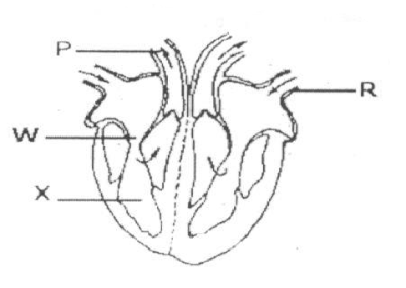

**(a) Name part marked X.  
……………………………………………………………………………………………**

**(b) What is the function of part marked W?  
……………………………………………………………………………………………**

**(c) To which body. organ does part marked P transports blood?  
……………………………………………………………………………………………**

**(d) Which type of blood is transported through blood vessel marked R?  
……………………………………………………………………………………………**

**48(a) What is the importance of oxygen in respiration?  
……………………………………………………………………………………………**

**(b) Mention two by-products from respiration.  
……………………………………………………………………………………………**

**(c) Mention one danger of having too much carbon dioxide in the body.  
……………………………………………………………………………………………**

**49. The diagram below is of a human skin. Use it to answer the questions that follow.**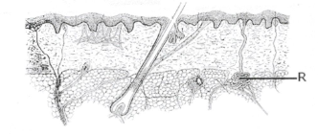

**a) To which body system does the organ in the diagram belong?  
……………………………………………………………………………………………**

**b) Name part marked R.  
……………………………………………………………………………………………**

**c) Mention any one function of the organ shown in the diagram.  
……………………………………………………………………………………………**

**d) Give one way of keeping the organ in a healthy and good condition.  
……………………………………………………………………………………………**

**50a) What is an invertebrate?  
……………………………………………………………………………………………**

**……………………………………………………………………………………………**

**b) To which group of invertebrates do insects belong?  
……………………………………………………………………………………………**

**c) How does a snail protect itself from enemies?  
……………………………………………………………………………………………**

**d)What type of skeleton do insects have?  
……………………………………………………………………………………………**

**51 a) State two ways how man destroys the environment.  
……………………………………………………………………………………………**

**……………………………………………………………………………………………**

**b) State two ways of protecting the environment.  
……………………………………………………………………………………………**

**……………………………………………………………………………………………**

**52. Complete the table below correctly.**

|  |  |  |
| --- | --- | --- |
| **DISEASE** | **CAUSE** | **MODE OF TRASMISSION** |
| **Trachoma** | **………………………….** | **Housefly** |
| **Sleeping sickness** | **Trypasoma** | **…………………………….** |
| **……………………………** | **Plasmodia** | **Female anopheles mosquito** |
| **Rabies** | **Virus** | **…………………………….** |

**53 State the use of the following instruments.**

**(a) an anemometer  
……………………………………………………………………………………………**

**(b) hygrometer  
……………………………………………………………………………………………**

**(c) barometer  
……………………………………………………………………………………………**

**(d) hydrometer  
……………………………………………………………………………………………**

**54. What do we call each of the following operations?**

**(a) removing some crops from an overcrowded field.  
……………………………………………………………………………………………**

**(b) collecting semen from a selected bull and injecting it into the body of a female.  
……………………………………………………………………………………………**

**c) separating productive animals from unproductive ones.  
……………………………………………………………………………………………**

**d) giving liquid medicine to an animal using a gun.  
……………………………………………………………………………………………**

**55 a) Why do the joints ¡n the skull not require synovial fluid?  
……………………………………………………………………………………………**

**……………………………………………………………………………………………**

**b)Why are people not immunized against HIV?  
……………………………………………………………………………………………**

**……………………………………………………………………………………………**

**c) Why cant people see around corners?  
……………………………………………………………………………………………**

**……………………………………………………………………………………………**

**d) Why do plants not make food at night?  
……………………………………………………………………………………………**

**……………………………………………………………………………………………**

**END**

**ITEM SEVEN**

**SECTION A:**

**1. Write any one source of light that uses paraffin as fuel.  
……………………………………………………………………………………………**

**2. Why would you group a duck and a goose in the same group of birds?  
……………………………………………………………………………………………**

**3. In the space provided below, draw molecules as they appear in solids.**

**4. Which component of the environment ¡s a habitat for fish and frogs?  
……………………………………………………………………………………………**

**5. State the function on root tubers to a cassava plant.  
……………………………………………………………………………………………**

**6. Draw and show the effect of heat on the water in the open container.**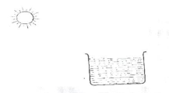

**7. Identify one example of a group of simple machines.  
……………………………………………………………………………………………**

**8. Which of these two body organs is used for breathing: a nose, lungs?  
……………………………………………………………………………………………**

**9. Suggest any one activity a person could do to keep good health of the alimentary organs.  
……………………………………………………………………………………………**

**10. Mention any one thing we use to clean hair.  
……………………………………………………………………………………………**

**11. In which way is cockroach similar to a housefly as vectors?  
……………………………………………………………………………………………**

**12. Suggest any one thing local leaders could do to reduce on road accidents on busy roads.  
……………………………………………………………………………………………**

**13. Suggest one activity carried out to save a person who has taken rat poison.  
……………………………………………………………………………………………**

**14. State any one danger of living in a room with an active smoker.  
……………………………………………………………………………………………**

**15. Mention the cattle parasite that spreads East Coast Fever.  
……………………………………………………………………………………………**

**16. Write the element of PHC practiced when a person feeds on a balanced diet.  
……………………………………………………………………………………………**

**17. Name any one member of a family who could properly teach babies between 2 — 4 years of age.  
……………………………………………………………………………………………**

**18. How do we care for our bones in the body?  
……………………………………………………………………………………………**

**19. Which gametes in the human reproductive system work in the same way as pollen grains in a flower?  
……………………………………………………………………………………………**

**20. Identify the form of energy a dry cell contains when it has just been manufactured.  
……………………………………………………………………………………………**

**21. Give a reason why ‘plants are renewable resources.  
……………………………………………………………………………………………**

**22. Mention any common pest of banana crops.  
……………………………………………………………………………………………**

**23. What first aid would you give to a fainted casualty?  
……………………………………………………………………………………………**

**24. Name one disease of the digestive system.  
……………………………………………………………………………………………**

**25. Write the similarity in function between part marked R on the diagram of an insect with the human lungs.**

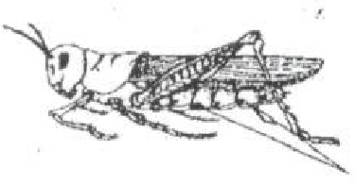**R  
……………………………………………………………………………………………**

**26. How would you protect a house ¡n a home against strong winds?  
……………………………………………………………………………………………**

**27. Write any one activity a person does to control the spread of trachoma.  
……………………………………………………………………………………………**

**28. In one sentence give one activity carried out to improve on soil fertility.  
……………………………………………………………………………………………**

**29. List one social problem that affects the health of adolescents.  
……………………………………………………………………………………………**

**30. Define the word “food path”.  
……………………………………………………………………………………………**

**31. Mention the name of the thigh bone.  
……………………………………………………………………………………………**

**32. How do first class levers make work easy?  
……………………………………………………………………………………………**

**33. Mass is the amount of matter in an object. Give the standard units used in measuring Mass.  
……………………………………………………………………………………………**

**The diagram shows part of the digestive system. Study it and answer question 34.**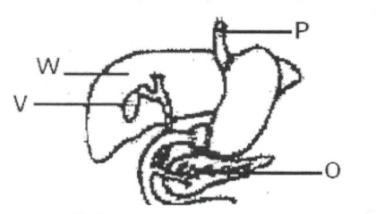

**34. Outline the use of part marked O during food digestion.  
……………………………………………………………………………………………**

**35. Where in the respiratory system is air moistened warmed before it goes to the lungs?  
……………………………………………………………………………………………**

**36. Apart from death, identify any other effect caused by road accidents on a person.  
……………………………………………………………………………………………**

**37, Name the part of the circulatory system shown in the diagram below.**

 **……………………………………………………………………………………………**

**38. Identify the lens that can be used to correct short sightedness.  
……………………………………………………………………………………………**

**39. How does the electrical method differ from stroking method while making a magnet?  
……………………………………………………………………………………………**

**40. State one activity done by a poultry farmer to control vices among birds.  
……………………………………………………………………………………………**

**Section B**

**41(a) Name the opposing force that works between to moving surfaces.  
……………………………………………………………………………………………**

**(b) Write two forms o0f energy produced by the force named ¡n (a) above.  
……………………………………………………………………………………………  
……………………………………………………………………………………………**

**(c) By use of an arrow, indicate the structures on the sports shoes that increase friction as s person putting on the shoes is walking.**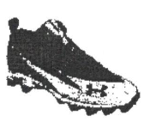

**42. The diagram below shows two cooling containers. Container A is a plastic and container B is metallic.**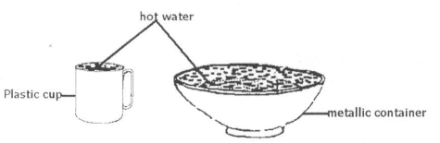

**(a) Which container cools the water faster?  
……………………………………………………………………………………………**

**(b) Give a reason to support your answer in (a) above.  
……………………………………………………………………………………………**

**(c) Identify the process that enables water to cool down.  
……………………………………………………………………………………………**

**(d) Name any natural change where the process name in (C) above takes place.  
……………………………………………………………………………………………**

**43(a) What is personal hygiene?  
……………………………………………………………………………………………**

**……………………………………………………………………………………………**

**(b) Write two activities a person carries out to keep clothes clean.  
……………………………………………………………………………………………**

**……………………………………………………………………………………………**

**(c) Suggest any one danger of not keeping clothes clean.  
……………………………………………………………………………………………**

**44. Match the following items correctly.**

**PART FOOD DIGESTED**

**Mouth milk sugars**

**Duodenum cooked starch**

**Stomach fats**

**Lactose proteins**

**45. The diagram below shows two root systems. Study them carefully and answer the following questions.**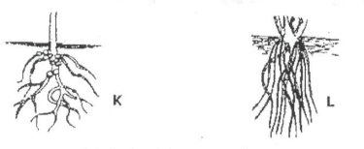

**(a) Identify the root systems labeled with letters K and L.  
………………………………………………………………………………………….**

**(b) Write two uses of roots to plants.  
………………………………………………………………………………………….**

**46(a) Give two domestic appliances that use both electricity and magnets.  
………………………………………………………………………………………….**

**The diagram below shows a simple electric circuit. Use it to answer the questions that follow.**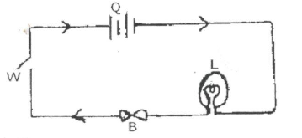

**(b) Name part marked B.  
……………………………………………………………………………………………**

**(C) What is the voltage in the simple electric circuit shown above?  
……………………………………………………………………………………………**

**47(a) Define the term skeleton.  
……………………………………………………………………………………………**

**……………………………………………………………………………………………**

**(b) Write any two functions of a human skeleton.  
……………………………………………………………………………………………**

**……………………………………………………………………………………………**

**(C) In which is a skeleton in a goat different from that of a bee?  
……………………………………………………………………………………………**

**48(a) Write any three types of chicken reared in Uganda.  
……………………………………………………………………………………………**

**……………………………………………………………………………………………**

**……………………………………………………………………………………………**

**(b) List any one product obtained from poltry.  
……………………………………………………………………………………………**

**49(a) What name is given to the diseases we due to poor feeding?  
……………………………………………………………………………………………**

**(b) Give two examples of such diseases as mentioned in (a) above.  
……………………………………………………………………………………………**

**……………………………………………………………………………………………**

**(c) Suggest one way of preventing such diseases.  
……………………………………………………………………………………………**

**50(a) List any two common types of changes in the environment.  
……………………………………………………………………………………………**

**……………………………………………………………………………………………**

**(b) To which type of change does rusting belong?  
……………………………………………………………………………………………**

**Cc) What piece of advice would you give to people to control rusting in metallic tools?  
……………………………………………………………………………………………**

**5 1(a) Mention any one example of energy resources.  
……………………………………………………………………………………………**

**(b) Why is the item you have given in (a) above called an energy resource?  
……………………………………………………………………………………………**

**(c) Mention one form of energy obtained from the above energy resource.  
……………………………………………………………………………………………**

**(d) Suggest the best way of handling energy resources that are non-renewable.  
……………………………………………………………………………………………**

**52(a) Give any two examples of diseases spread by mosquitoes.  
…………………………………………………………………………………………………………………………………………………………………………………………**

**(b) Mention the cause of one of the diseases you have named in (a) above.  
……………………………………………………………………………………………**

**(c) How would you control the spread of such diseases without polluting the environment?  
……………………………………………………………………………………………**

**53(a) Identify the sounds made by the following animals:**

**(i) duck  
……………………………………………………………………………………………**

**(ii) dog  
……………………………………………………………………………………………**

**(b) Give one device used to produce sound.  
……………………………………………………………………………………………**

**(c) Give one example of a local stringed instrument.  
……………………………………………………………………………………………**

**54(a) List two body organs which work together to make proper circulation of blood and oxygen in the body.  
……………………………………………………………………………………………**

**……………………………………………………………………………………………**

**(b) Give the role of each of the organs you have named in (a) above in blood circulation:  
……………………………………………………………………………………………**

**55(a) Identify any two requirements for starting a livestock farm.   
……………………………………………………………………………………………**

**……………………………………………………………………………………………**

**(b) Give any two advantages of keeping records on a farm.  
……………………………………………………………………………………………**

**……………………………………………………………………………………………**

**END**

**ITEM EIGHT**

**SECTION A:**

**1. Name the body organ that detects the smell of good food.  
……………………………………………………………………………………………**

**2. Why ¡s ¡t dangerous to touch uninsulated electric wires?  
……………………………………………………………………………………………**

**3. Apart from discs and memory cards, name other device that can be used to store sound.  
……………………………………………………………………………………………**

**4. Identify one activity of man that leads to misuse of wetlands.  
……………………………………………………………………………………………**

**5. Of what use is a crop in the digestive process of birds?  
……………………………………………………………………………………………**

**6. What force ¡s used to sharpen tools?  
……………………………………………………………………………………………**

**7. What property of magnetism is illustrated below?**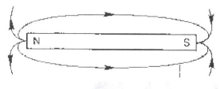

**8. Oxygen is one of the components of air. How can it a danger to man?  
……………………………………………………………………………………………**

**9. How is the process of decomposition (decay) useful to farmers?  
……………………………………………………………………………………………**

**10, Mention one item used in keeping the human body clean.  
……………………………………………………………………………………………**

**11. Why is a blanket able to keep a person warm at night?  
……………………………………………………………………………………………**

**12. How does polio affect the skeletal system?  
……………………………………………………………………………………………**

**13. Mention one factor that leads to food poisoning.  
……………………………………………………………………………………………**

**14. Mosses are plants and mushrooms are fungi. How are mosses and mushrooms similar?  
……………………………………………………………………………………………**

**15. State the use of the blood cells shown in the diagram below.**

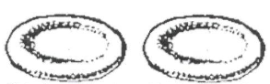 **……………………………………………………………………………………………**

**16. State the method used to find the volume of a papaw.  
……………………………………………………………………………………………**

**17. Write down one exotic beef breed of cattle.  
……………………………………………………………………………………………**

**18. Give one importance of a child health card to parents.  
……………………………………………………………………………………………**

**19. In which way are regular physical exercises important to the body?  
……………………………………………………………………………………………**

**20. State the element of PHC that controls population growth.  
……………………………………………………………………………………………**

**21. Which pest can be controlled using traps?  
……………………………………………………………………………………………**

**22. Give one health need of a pregnant woman.**

**……………………………………………………………………………………………**

**23. Why should every family have enough food?  
……………………………………………………………………………………………**

**24. What makes the skin a storage organ?  
……………………………………………………………………………………………**

**25. Mention the activity farmers carry out using the tool below.**

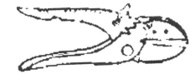 **……………………………………………………………………………………………**

**26. Give the vector that breeds in rubbish heaps.  
……………………………………………………………………………………………**

**27. State the danger of sharing drugs meant for one patient.  
……………………………………………………………………………………………**

**28. Write one living component of the environment.  
……………………………………………………………………………………………**

**29. State one health benefit of cooking food.  
……………………………………………………………………………………………**

**30. Apart from filtration, identify one other way of making dirty water clean.  
……………………………………………………………………………………………**

**31. Which sexually transmitted disease affects eyes?  
……………………………………………………………………………………………**

**32. What happens when light rays meet a transparent material?  
……………………………………………………………………………………………**

**33. Where does re-absorption of useful materials take place in the kidney?  
……………………………………………………………………………………………**

**34. how ¡s a sperm cell in human beings similar to pollen grains in plants?  
……………………………………………………………………………………………**

**35. Give one advantage of the paddock system in cattle keeping.  
……………………………………………………………………………………………**

**36. Why is a latrine important in a home?  
……………………………………………………………………………………………**

**37. Name the disorder that affects the digestive system due to lack of teeth.  
……………………………………………………………………………………………**

**38. Write down one cause of violence in a home.  
……………………………………………………………………………………………**

**39. How do trees clean the environment?  
……………………………………………………………………………………………**

**40. Name one group of living things.  
……………………………………………………………………………………………**

**SECTION B**

**41. The diagram shows symbols representing parts of an electric circuit.**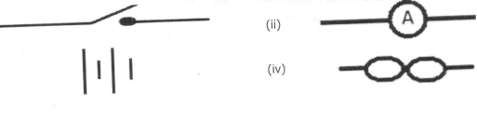

**(a) Identify the parts shown by symbols (i) and (ii).  
……………………………………………………………………………………………**

**(b) State the form of energy stored in the part represented by symbol (iii).  
……………………………………………………………………………………………**

**Cc) Give the function of the part represented by symbol marked (iv).  
……………………………………………………………………………………………**

**42(a) Name two energy resources got from water.  
……………………………………………………………………………………………**

**(b) How are the above mentioned resources friendly to the environment?  
……………………………………………………………………………………………**

**43(a) Outline the two types of immunity.  
……………………………………………………………………………………………**

**(b) What immunisable disease is a water borne disease?  
……………………………………………………………………………………………**

**……………………………………………………………………………………………**

**(c) Why is getting immunity after a long illness not a good method?  
……………………………………………………………………………………………**

**……………………………………………………………………………………………**

**44(a) Explain the following terms in crop growing:**

**(i) thinning  
……………………………………………………………………………………………**

**(ii) weeding  
……………………………………………………………………………………………**

**(b) Give two advantages of mulching.  
……………………………………………………………………………………………**

**……………………………………………………………………………………………**

**45(a) How does a human body allow movement?  
……………………………………………………………………………………………**

**(b) Name the type of joint found in the cranium of the skull.  
……………………………………………………………………………………………**

**(c) Write down two ways of keeping the skeletal system in a good working condition.  
……………………………………………………………………………………………**

**……………………………………………………………………………………………**

**46. A village chief uses a drum to call people for community work.**

**(a) How does the sound from the drum reach people?  
……………………………………………………………………………………………**

**(b) How does the drum produce sound?  
……………………………………………………………………………………………**

**(c) Apart from the drum, name any other percussion instrument.  
……………………………………………………………………………………………**

**(d) How can a person playing a drum producing sound of different pitch?  
……………………………………………………………………………………………**

**47. The diagram below is of a plant. Use it to answer the questions that follow.**

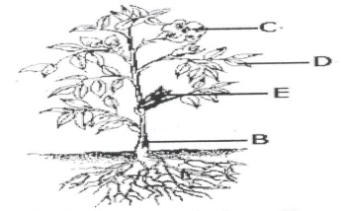

**(a) Of what importance is part C to a plant?  
……………………………………………………………………………………………**

**(b) Name the parts labeled B and E.  
……………………………………………………………………………………………**

**(c) Apart from photosynthesis, give any other process that takes place in part D.  
……………………………………………………………………………………………**

**48(a) Kagolo earns money from charcoal burning. In which two ways is this activity bad to the environment?  
……………………………………………………………………………………………**

**(b) Suggest two ways charcoal use can be reduced.  
……………………………………………………………………………………………**

**……………………………………………………………………………………………**

**49. The data shows information collected from two homes of Kato and Wasswa.**

|  |  |
| --- | --- |
| **Kato’s home** | **Wasswa’s home** |
| **Has a latrine**  **Has a plate rack**  **Boils water for drinking**  **Has a clean a well maintained compound** | **Use bush for defection**  **Has a place rack**  **Boils water for drinking**  **Has a dirty and busy compound.** |

**(a) Which of the homes is likely to have health problems?  
……………………………………………………………………………………………**

**(b) Identify the two things likely to affect health in the home named in (a) above.  
……………………………………………………………………………………………**

**(c) Mention one disease likely to affect people living ¡n the home you have named in (a) above.  
……………………………………………………………………………………………**

**50(a) Under what condition may a magnet lose its magnetism?  
……………………………………………………………………………………………**

**(b) Give two ways how magnets are important in our everyday life.  
……………………………………………………………………………………………**

**……………………………………………………………………………………………**

**5 1(a) State two factors that can lead one to smoke.  
……………………………………………………………………………………………**

**……………………………………………………………………………………………**

**b) Give one poisonous substance found in tobacco smoke.  
……………………………………………………………………………………………**

**c) Name the crop from which cigarettes are made.  
……………………………………………………………………………………………**

**52. a) What is mechanical advantage in relation to machines?  
……………………………………………………………………………………………**

**b) Under what group of machines is a nut cracker?  
……………………………………………………………………………………………**

**c) Name one force that affects the efficiency of a machine.  
……………………………………………………………………………………………**

**d) Draw a wedge ¡n the space provided below.**

**Match the organs with their functions.**

**kidney**

**liver**

**brain**

**pancreas**

**produces insulin**

**stores information**

**filters harmful products from blood**

**produces heat in the bod**

**54. Use the diagram of an egg given below to answer the questions that follows.**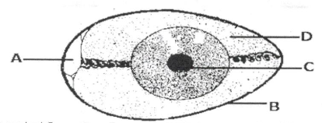

**a) Name the part marked C.  
……………………………………………………………………………………………**

**b) Give the functions of parts A and D.  
……………………………………………………………………………………………**

**c) Why is part B porous?  
……………………………………………………………………………………………**

**55 a) Identify two natural sources of light.  
……………………………………………………………………………………………**

**How is light useful to plants?  
……………………………………………………………………………………………**

**Why can’t people see around corners?**

**……………………………………………………………………………………………**

**ITEM NINE**

**SECTION A (40 MARKS)**

**1. Which main body part of an insect has breathing organs?  
……………………………………………………………………………………………**

**2. Name the blood vessel which takes blood to the kidney.  
……………………………………………………………………………………………**

**3. Name the energy resource obtained from the sun.  
……………………………………………………………………………………………**

**4. Mention any one factor that affects condensation.  
……………………………………………………………………………………………**

**5. State the difference between pitch and volume of sound?  
……………………………………………………………………………………………**

**The diagram below shows a simple machine used to drill holes in wood. Use it to answer questions 6 and 7.**

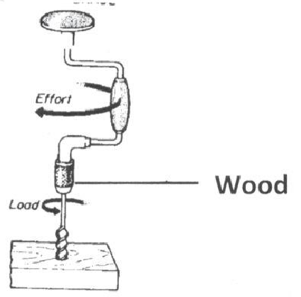

**6. To which class of levers does the machine above belong?  
……………………………………………………………………………………………**

**7. Use an arrow and letter X to show the load.  
……………………………………………………………………………………………**

**8. State any one way of reducing moisture in a poultry house.  
……………………………………………………………………………………………**

**1. Mention one reason why some flowers produce scent.  
……………………………………………………………………………………………**

**11. State the difference between the feeding of a female anopheles mosquito and a housefly.**

**12. Give any one way in which boiled drinking water can get contaminated.  
……………………………………………………………………………………………**

**13. Name the biggest sense organ of man’s body.  
……………………………………………………………………………………………**

**14. Give any one way of making an electro-magnet stronger.  
……………………………………………………………………………………………**

**15. State any one way in which parents can prevent scurvy from affecting the children.  
……………………………………………………………………………………………**

**16. Give any one way in which some plants are adapted to dry conditions.  
……………………………………………………………………………………………**

**17. Mention any one result of not using birth control methods by married people.  
……………………………………………………………………………………………**

**18. Why is a crocodile able to live in water and on land?  
……………………………………………………………………………………………**

**19. Give the use of a lactometer to a cattle farmer.  
……………………………………………………………………………………………**

**20. Give one reason why young children should be given food rich in proteins.  
……………………………………………………………………………………………**

**The diagram below shows parts of a joint. Study and use it to answer question 21 and 22.**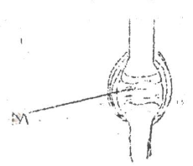

**21, Name the part marked with letter M.  
……………………………………………………………………………………………**

**22. Using letter N, show the tibia on the above diagram.  
……………………………………………………………………………………………**

**23. State any one method of controlling moisture loss from soil.  
……………………………………………………………………………………………**

**24. Why do health workers advise us to keep the grass near our homes short?  
……………………………………………………………………………………………**

**25. How does water in the body help to make digestion of food easy?  
……………………………………………………………………………………………**

**26. How is a telescope different from a microscope in terms of function?  
……………………………………………………………………………………………**

**27. By what means do ferns reproduce?  
……………………………………………………………………………………………**

**28. Apart from swallowing poison into the digestive system, state another way germs can get into the body.  
……………………………………………………………………………………………**

**29. Why are bees able to carry pollen grains from one flower to another?  
……………………………………………………………………………………………**

**30. Give an example of a carnivorous mammal which is a scavenger.  
……………………………………………………………………………………………**

**31. Name the human body system which moves the body.  
……………………………………………………………………………………………**

**32. In the .space below, draw a kitchen utensil rack common in homes.**

**33. State one disadvantage of depending on wood fuel as an energy source in a home.  
……………………………………………………………………………………………**

**34. Name the insect pest for maize common in maize gardens.  
……………………………………………………………………………………………**

**35. Apart from providing heat and light, give another use of electricity in a home.  
……………………………………………………………………………………………**

**The diagram below shows a musical instrument. Study and use it to answer questions 36 and 37.**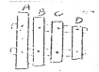

**36. Which of the wooden bars marked A, B, C, D produces sound of the lowest pitch?  
……………………………………………………………………………………………**

**37. Give a reason for your answer in 36 above.  
……………………………………………………………………………………………**

**38. State the importance of bacteria in food chain.  
……………………………………………………………………………………………**

**39. Name the virus that causes AIDS.  
……………………………………………………………………………………………**

**40. State one reason why farmers stake banana plants.  
……………………………………………………………………………………………**

**SECTION B**

**41. a) Give any two materials from which organic fertilizers are obtained  
……………………………………………………………………………………………**

**b) State any two bad effects of artificial fertilizers on soil  
……………………………………………………………………………………………**

**……………………………………………………………………………………………**

**42. a) Give one reason why the sick and the elderly are grouped as vulnerable  
……………………………………………………………………………………………**

**b) Apart from the sick and the elderly, mention any other two groups of vulnerable people.  
……………………………………………………………………………………………**

**c) Mention one reason why vulnerable people need special feeding.  
……………………………………………………………………………………………**

**43. The diagram below shows a plant. Study and use it to answer the questions that follow.**

**a) To which group of plants does the above plant belong?**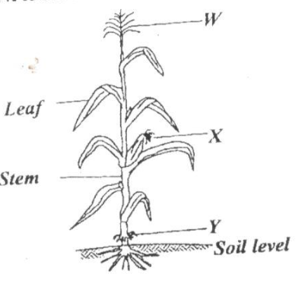

**b) What type of root system does the plant have?  
……………………………………………………………………………………………**

**c) State the importance of part labeled W to the plant.  
……………………………………………………………………………………………**

**d) Name the part marked Y.  
……………………………………………………………………………………………**

**44. a) Name the two parts that a skull is composed of.  
……………………………………………………………………………………………**

**b) Which one of the parts named above protects the brain?  
……………………………………………………………………………………………**

**c) State one way of keeping the skull strong.  
……………………………………………………………………………………………**

**45. a) State the role of each type of bees below in a hive.**

**i) drone bee   
……………………………………………………………………………………………**

**ii) worker bee   
……………………………………………………………………………………………**

**b) Name the material used by bees to seal small cracks and gaps in the hive.  
……………………………………………………………………………………………**

**c) Give the importance of keeping bees.  
……………………………………………………………………………………………**

**46. The table below shows diseases the vectors that spread them and the disease causing germ. Study and complete it correctly.**

|  |  |  |
| --- | --- | --- |
| **Diseases** | **Vector** | **Germ** |
| **Malaria** | **Female anopheles mosquito** | **………………………….** |
| **Sleeping sickness** | **……………………………** | **Protozoa** |
| **……………………………** | **Rat fleas** | **Bacteria** |
| **Trachoma** | **Houseflies** | **…………………………..** |

**47. a) State the importance of the sun to life of plants.  
…………………………………………………………………………………………….**

**b) Name the part of a plant which makes food for the plant.  
…………………………………………………………………………………………….**

**c) Write the term used to mean plant response to light.  
…………………………………………………………………………………………….**

**d) State one reason why mushrooms cannot make their own food.  
…………………………………………………………………………………………….**

**48. The diagram below shows a method of cooking food. Study and use it to answer the questions that follow.**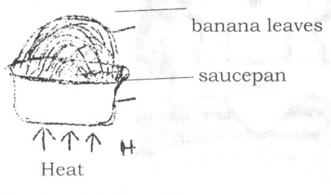

**a) Name the material from which the saucepan was made.  
…………………………………………………………………………………………….**

**b) State the use of banana leaves in the process shown above.  
…………………………………………………………………………………………….**

**c) Give any two factors which can affect the amount of heat from the source shown above.  
…………………………………………………………………………………………….**

**49. The table below shows parts of a rabbit in A and that of a fish in B.**

|  |  |
| --- | --- |
| **A (rabbit)** | **B (fish)** |
| **Ear**  **Fur**  **Lungs**  **Foot** | **Fins**  **Gills**  **Nostrils**  **Scales** |

**For each of the parts of a rabbit, write the part of a fish (from B) which performs a similar function.**

1. **Ear ………………………………………………………………………………….**
2. **Fur ………………………………………………………………………………….**
3. **Lungs………………………………………………………………………………..**
4. **Foot ………………………………………………………………………………..**

**50. a) Write in full S.T.I  
……………………………………………………………………………………………**

**b) Give any two bacterial diseases that people get through unprotected sex with an infected person.  
……………………………………………………………………………………………**

**c) Suggest one sure way a P7 child can avoid contracting STIs.  
……………………………………………………………………………………………**

**51. a) What is passive smoking?  
……………………………………………………………………………………………**

**……………………………………………………………………………………………**

**b) Give one reason why active smokers find it hard to leave smoking.  
……………………………………………………………………………………………**

**c) State any two effects of smoking to the family of a smoker.  
……………………………………………………………………………………………**

**52. a) Where does urine come from to enter the urinary bladder?  
……………………………………………………………………………………………**

**b) Why are we advised not to hold urine in the bladder for long?  
……………………………………………………………………………………………**

**c) Name the acid present in urine.  
……………………………………………………………………………………………**

**d) Name the path of urine out of the human body.  
……………………………………………………………………………………………**

**53. The diagram below shows a weather instrument. Study and use it to answer the questions that follow**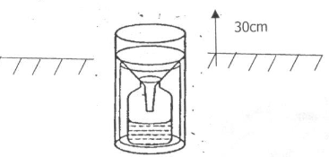

**a) Name the weather instrument shown ¡n the diagram above.  
……………………………………………………………………………………………**

**b) What is the use of the instrument above at a weather station?  
……………………………………………………………………………………………**

**c) Give one reason why the above instrument should be put in an open place  
……………………………………………………………………………………………**

**d) Name the element of weather which influence the way people dress.  
……………………………………………………………………………………………**

**……………………………………………………………………………………………**

**54. a) To which group of mammals do bats belong?  
……………………………………………………………………………………………**

**b) Name the type of bats that feed on blood from other animals.  
……………………………………………………………………………………………**

**c) State any two ways in which sound waves and echoes are important to bats  
……………………………………………………………………………………………**

**……………………………………………………………………………………………**

**55. a) Apart from predators, mention any two poultry pests.  
……………………………………………………………………………………………**

**b) State any two ways of keeping predators out of a poultry house.  
……………………………………………………………………………………………**

**END**

**ITEM TEN**

**SECTION A:**

**1. Mention any one type of chicken reared in your community.  
……………………………………………………………………………………………**

**2. State one characteristic that is common to both mammals and birds.  
……………………………………………………………………………………………**

**3. Give any one reason why people keep cattle.  
……………………………………………………………………………………………**

**4. State one reason why pregnant women should go for antenatal care.  
……………………………………………………………………………………………**

**5. The diagram below is of a signpost. How is the message on the post useful to a P.7 pupil?**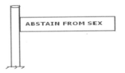

**6. Why is humus a very important component of soil?  
……………………………………………………………………………………………**

**7. State one example of a spore bearing plant.  
……………………………………………………………………………………………**

**The diagram shows electric wires on poles. Use it to answer question 8.**

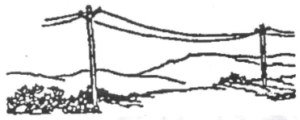 **……………………………………………………………………………………………**

**8. Basing on the appearance of the wires, what was the weather of the atmosphere?  
……………………………………………………………………………………………**

**9. Why are the wires left sagging during installation?  
……………………………………………………………………………………………**

**10. Write down any one component of air.  
……………………………………………………………………………………………**

**11. Outline any one cause of dehydration to babies.  
……………………………………………………………………………………………**

**12. Give a reason why drinking water should be boiled.  
……………………………………………………………………………………………**

**The diagram below shows part of a plant. Use it to answer questions 13 and 14.**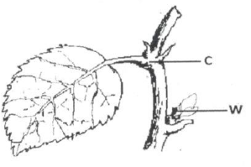

**13. Name part marked C.  
……………………………………………………………………………………………**

**14. How is part marked W important?  
……………………………………………………………………………………………**

**15. Mention any one way of saving energy in our environment.  
……………………………………………………………………………………………**

**16. State one effect of smoking by a pregnant woman.  
……………………………………………………………………………………………**

**17. How is the Eustachian tube important to the ear?  
……………………………………………………………………………………………**

**18. Why are mango crops regarded as perennial crops?  
……………………………………………………………………………………………**

**19. How are the kidneys important in the body?  
……………………………………………………………………………………………**

**20. State one vector borne disease.  
……………………………………………………………………………………………**

**21. By what process does water change into ice?  
……………………………………………………………………………………………**

**22. Why was a toilet made in a way that after flushing water remains under the bowl?  
……………………………………………………………………………………………**

**23. Which body organ helps a P.6 girl to identify the best perfume to wear?  
……………………………………………………………………………………………**

**24. State any one anti-social behaviour at school.  
……………………………………………………………………………………………**

**25. Why ¡s rusting of metals regarded as a chemical change?  
……………………………………………………………………………………………**

**26. State one fuel commonly used at home.  
……………………………………………………………………………………………**

**27. How can tapeworm infestation be controlled in our communities?  
……………………………………………………………………………………………**

**28. By what process does dust spread in the air after sweeping?  
……………………………………………………………………………………………**

**29. State the living organism necessary for the production of butter from milk.  
……………………………………………………………………………………………**

**30. Give one example of an ecto-parasite in goats.  
……………………………………………………………………………………………**

**31. State any one petroleum product.  
……………………………………………………………………………………………**

**Use the diagram below to answer questions 32 and 33.**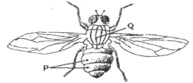

**32. Name part marked Q.  
……………………………………………………………………………………………**

**33. How is part marked P useful to the insect?  
……………………………………………………………………………………………**

**34. Write HIV in full.  
……………………………………………………………………………………………**

**35. Why is it important to recycle polythene wastes?  
……………………………………………………………………………………………**

**36. Mention one way of controlling mosquitoes while at the larva stage.  
……………………………………………………………………………………………**

**37. Why is Tuberculosis immunised at birth?  
……………………………………………………………………………………………**

**38. Mention the term used to describe the drugs used to treat common disease in a community.  
……………………………………………………………………………………………**

**39. State one way the appearance of arteries is different from that of veins.  
……………………………………………………………………………………………**

**40. How does afforestation conserve the environment?  
……………………………………………………………………………………………**

**Section B**

**41. The diagram below shows a electric circuit. Use it to answer the question about it.**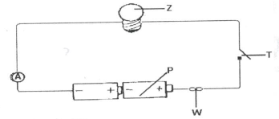

**(a) Name part marked W.  
……………………………………………………………………………………………**

**(b) How is part marked T useful to the circuit?  
……………………………………………………………………………………………**

**(c) State one energy change that takes place at Z when the switch is closed.  
……………………………………………………………………………………………**

**(d) Calculate the amount of voltage that was used in the circuit.  
……………………………………………………………………………………………**

**42(a) Write down the method used to make alcohol of a high concentration.  
……………………………………………………………………………………………**

**(b) Give one reason why people take alcohol.  
……………………………………………………………………………………………**

**(c) State one danger of alcohol to an individual.  
……………………………………………………………………………………………**

**(d) Mention the low that forbids a P.7 child from taking alcohol.  
……………………………………………………………………………………………**

**43(a) How are the following bees important in a hive?**

**(i) worker bees  
……………………………………………………………………………………………**

**(ii) queen bee  
……………………………………………………………………………………………**

**(b) Why is it that there are always very few drone bees in a hive?  
……………………………………………………………………………………………**

**(c) How can man benefit from the presence of bees in the environment?  
……………………………………………………………………………………………**

**44(a) What is personal hygiene?  
……………………………………………………………………………………………**

**……………………………………………………………………………………………**

**(b) State two activities that can be carried out to promote personal hygiene.  
……………………………………………………………………………………………**

**……………………………………………………………………………………………**

**(c) Single out any one item you can use to maintain your personal hygiene.  
……………………………………………………………………………………………**

**45(a) What is a skeleton?  
……………………………………………………………………………………………**

**……………………………………………………………………………………………**

**(b) State two ways in which a skeleton is useful to the body.  
……………………………………………………………………………………………**

**……………………………………………………………………………………………**

**(c) Mention any disease that can affect the skeletal system.  
……………………………………………………………………………………………**

**46. The diagram below shows an experiment that was carried out in a science lesson. Use it to answer the questions that follow.**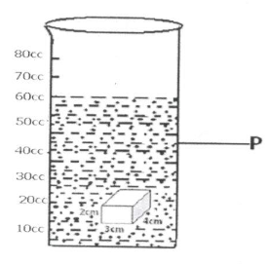

**(a) What method was used to find the volume of the cuboid?  
……………………………………………………………………………………………**

**(b) Name container marked P.  
……………………………………………………………………………………………**

**(c) At what level will water be when the cuboid is removed from the water in the experiment? (2 marks)  
……………………………………………………………………………………………**

**47(a) How ¡s rain formation important in the environment?  
……………………………………………………………………………………………**

**……………………………………………………………………………………………**

**(b) State any one process that is involved ¡n the rain cycle.  
……………………………………………………………………………………………**

**(c) Name the clouds that are responsible for giving us rain.  
……………………………………………………………………………………………**

**(d) Besides giving us rain, how else are such clouds mentioned in (C) above useful to man?  
……………………………………………………………………………………………**

**48(a) Define the following terms,**

**(i) Transplanting  
……………………………………………………………………………………………**

**……………………………………………………………………………………………**

**(ii) Pruning  
……………………………………………………………………………………………**

**……………………………………………………………………………………………**

**(b) State the tool used during transplanting.  
……………………………………………………………………………………………**

**(c) Give one reason why farmers mulch their gardens.  
……………………………………………………………………………………………**

**49(a) What is photosynthesis?  
……………………………………………………………………………………………**

**……………………………………………………………………………………………**

**(b) State any one condition necessary for photosynthesis to take place.  
……………………………………………………………………………………………**

**(c) By looking at a plant, how can you tell that the plant is monocotyledonous one?  
……………………………………………………………………………………………**

**(d) Name one plant that stores its food ¡n the leaves.  
……………………………………………………………………………………………**

**50. The diagram below shows feet of different birds. Use it to answer the questions that follow.**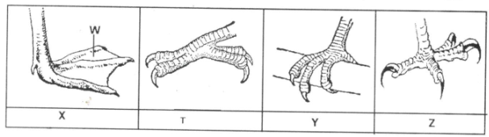

**(a) Name part marked W on the foot marked X..  
……………………………………………………………………………………………**

**(b) What does the bird with foot marked Z fed on?  
……………………………………………………………………………………………**

**(c) Identify the group of birds with foot marked T.  
……………………………………………………………………………………………**

**(d) State one group of a bird with foot marked Y.  
……………………………………………………………………………………………**

**51(a) Name two enzymes produced by the pancreas.  
……………………………………………………………………………………………**

**(b) How are the enzymes important in the body?  
……………………………………………………………………………………………**

**(c) State any one characteristic of enzymes.  
……………………………………………………………………………………………**

**52. The diagram below shows three different types of teeth. Use it to answer the questions that follow.**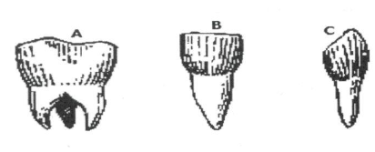

**(a) Name the tooth marked A.  
……………………………………………………………………………………………**

**(b) State the function of tooth marked C.  
……………………………………………………………………………………………**

**(c) How is tooth marked B adapted to its function?  
……………………………………………………………………………………………**

**(d) How many teeth should a normal adult person have?  
……………………………………………………………………………………………**

**53(a) What is food security?  
……………………………………………………………………………………………**

**……………………………………………………………………………………………**

**(b) State two causes of food insecurity.  
……………………………………………………………………………………………**

**……………………………………………………………………………………………**

**(c) Mention one way you can ensure food security.  
……………………………………………………………………………………………**

**54(a) Mention one handling structure on a livestock farm.  
……………………………………………………………………………………………**

**(b) How is the structure mentioned in (a) above useful to the livestock farmer?  
……………………………………………………………………………………………**

**(c) Mention one type of fence used in cattle management.  
……………………………………………………………………………………………**

**(d) Give one reason why it is important to fence off livestock animals.  
……………………………………………………………………………………………**

**……………………………………………………………………………………………**

**55(a) What is a foreign body?  
……………………………………………………………………………………………**

**……………………………………………………………………………………………**

**(b) State the first aid you can give to a person who has a foreign body in the following body parts.**

**(i) eyes  
……………………………………………………………………………………………**

**(ii) throat  
……………………………………………………………………………………………**

**(c) Why is it important to give first aid?  
……………………………………………………………………………………………**

**……………………………………………………………………………………………**

**END**

**ITEM ELEVEN**

**SECTION A: 40 MARKS**

**(Questions 1 to 40 carry one mark each)**

**1. Name one domestic animal used for protection in a home.  
……………………………………………………………………………………………**

**2. What type of farming should a farmer use ¡n order to harvest both crops and wood? (2009)  
……………………………………………………………………………………………**

**3. State one natural cause of a family failing to have enough food.  
……………………………………………………………………………………………**

**4. Give one reason why a tsefsefly is dangerous to cattle.  
……………………………………………………………………………………………**

**5. Name the kind of energy possessed by water at 100°C.   
……………………………………………………………………………………………**

**6. Why does a coin sink when it’s placed in a basin full of water?  
……………………………………………………………………………………………**

**7. State one effect of heat on a metal.  
……………………………………………………………………………………………**

**8. Write down one function of joints in a human body.  
……………………………………………………………………………………………**

**9. Write down one way ¡n which a Primary Seven pupil can help in the control of cholera in a community.  
……………………………………………………………………………………………**

**10. Arrange the following organisms in the correct order of a food chain, caterpillar  
……………………………………………………………………………………………**

**dog leaves birds**

**11. Sun birds visit flowers to get nectar. How do plants benefit from these birds?  
……………………………………………………………………………………………**

**The diagram below is of a simple circuit Use it to answer questions 12 and 13.**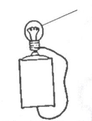

**12. Draw an arrow on line P to show the direction of the flow of electricity.**

**13. Apart from light, which other form of energy is produced at A?  
……………………………………………………………………………………………**

**14. Give a reason why drugs should be kept away from children.  
……………………………………………………………………………………………**

**15. Name the class of simple machines to which an axe belongs.  
……………………………………………………………………………………………**

**16. State one type of accident whose First Aid is to put the affected part of the body in cold water.  
……………………………………………………………………………………………**

**17, Name any one characteristic of seeds which are dispersed by wind.  
……………………………………………………………………………………………**

**18. State the compass direction in which a freely suspended magnet will rest.  
……………………………………………………………………………………………**

**19. Name the turning point of a machine.  
……………………………………………………………………………………………**

**20. How do conifers differ from other non-flowering plants?  
……………………………………………………………………………………………**

**21. How can the pitch of a string of a musical instrument be changed?  
……………………………………………………………………………………………**

**22. Give any one way in which the human liver can be kept in proper working condition.  
……………………………………………………………………………………………**

**The diagram below ís a section of a flower. Use it to answer questions 23 and 24.**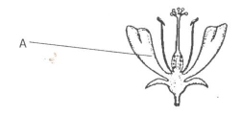

**23. Name the part marked A.  
……………………………………………………………………………………………**

**24. Use letter P to show the part that produces the male reproductive cells.**

**25. State one disadvantage of keeping fingernails long.  
……………………………………………………………………………………………**

**26. Name any one mammal that lives in water.  
……………………………………………………………………………………………**

**27. Why does a farmer cut off the leaves of a banana sucker before planting it?  
……………………………………………………………………………………………**

**28. Why is it important for a husband and his wife to be treated together if they have got gonorrhoea?  
……………………………………………………………………………………………**

**29. Why are electric wires left sagging loosely between poles during construction?**

**……………………………………………………………………………………………**

**30. Why does a clay-made charcoal stove use less charcoal than a metallic one?  
……………………………………………………………………………………………**

**31. State one way in which a child gets natural immunity.  
……………………………………………………………………………………………**

**The diagram below is of a common animal Use it to answer question 32.**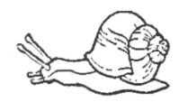

**32. Which disease does the above animal spread to humans?  
……………………………………………………………………………………………**

**33. Name the part of the human eye that works like the film in a camera.  
……………………………………………………………………………………………**

**34. Give any one way in which a single fixed pulley is used in a school.  
……………………………………………………………………………………………**

**35. How does a fish benefit from its slippery body?  
……………………………………………………………………………………………**

**36. Which deficiency disease is caused by lack of Vitamin D in children’s diet?  
……………………………………………………………………………………………**

**37. Why is it advisable to leave the pit of a VIP latrine open?  
……………………………………………………………………………………………**

**38. Name the cattle disease whose sign is a swollen and painful udder.  
……………………………………………………………………………………………**

**39. Which structures enable the trachea to remain open all the time?  
……………………………………………………………………………………………**

**The diagram below is of a mosquito larva. Use it to answer question 40.**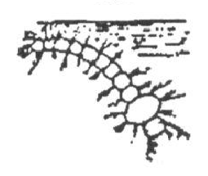

**40. What disease does the mosquito which develops from the above larva spread?  
……………………………………………………………………………………………**

**SECTION B**

**(Questions ¡n this section carry four marks each)**

**41(a) Which bone joins the pelvis and the tibia?  
……………………………………………………………………………………………**

**(b) Apart from movement, give any other two functions of the human skeleton.  
……………………………………………………………………………………………**

**(c) What is the function of tendons in a human body?  
……………………………………………………………………………………………**

**42. The table below shows food stuffs prepared in different families. Study it and answer the questions that follow.**

|  |  |  |  |
| --- | --- | --- | --- |
| **Family A** | **Family B** | **Family C** | **Family D** |
| **Matooke**  **Yams**  **Meat**  **Beans** | **Cassava**  **Beans**  **Posho**  **Yams** | **Potatoes**  **Posho**  **Cassava**  **Yams** | **Millet**  **Fish**  **Goat milk**  **Mangoes** |

**(a) Which family will be able to have vitamin C?  
……………………………………………………………………………………………**

**(b) Which family has proteins but lacks fats?  
……………………………………………………………………………………………**

**(C) What food nutrients are lacking in family A?  
……………………………………………………………………………………………**

**(d) Which family has almost a balanced diet?  
……………………………………………………………………………………………**

**43. Give any four ways in which plants depend on each other.  
……………………………………………………………………………………………**

**44. The diagram below shows a rabbit house. Use it to answer questions that follow.**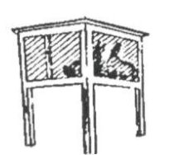

**(a) Give any one reason why the rabbit house is raised above the ground.  
……………………………………………………………………………………………**

**(b) Give aiiy two reasons why wire mesh is used in building a rabbit house.  
……………………………………………………………………………………………**

**(c) State any one thing that should be provided to the rabbit in the house.  
……………………………………………………………………………………………**

**45(a) Give any two characteristics that are common to a frog and a crocodile apart from being vertebrates.  
……………………………………………………………………………………………**

**(b) How is fertilization of a frog different from that of a crocodile?  
……………………………………………………………………………………………**

**(c) Name any one other vertebrate that can be classified with a frog.  
……………………………………………………………………………………………**

**46(a) Suggest two reasons why Young Farmer’s clubs are important in schools.  
……………………………………………………………………………………………**

**(b) Give any two activities that can be done by Young Farmer’s clubs in schools.  
……………………………………………………………………………………………**

**47. Equal amounts of water were poured onto soil A and 8 shown ¡n the diagram below. Study carefully the diagram and answer questions that follow.**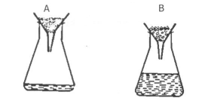

**(a) From which soil did more water drop?  
……………………………………………………………………………………………**

**(b) State why more water dropped from the soil you have named in (a) above.  
……………………………………………………………………………………………**

**(c) Name the type of soil in B.  
……………………………………………………………………………………………**

**(d) Give one use of the type of soil in A.  
……………………………………………………………………………………………**

**48(a) What name is given to the process that turns sugar to alcohol?  
……………………………………………………………………………………………**

**(b) Apart from making alcohol, state two other ways the process you have named in (a) can be useful to human beings.  
……………………………………………………………………………………………**

**(c) Name the fungus used in this process.  
……………………………………………………………………………………………**

**49(a) Which organ removes urine from the body?  
……………………………………………………………………………………………**

**(b) To which body system does the organ that removes urine from the body belong?  
……………………………………………………………………………………………**

**(c) Where does urine collect before ¡t is removed from the body?  
……………………………………………………………………………………………**

**(d) Name one substance found in urine.  
……………………………………………………………………………………………**

**The diagram below shows a method of making a magnet. Study it and use it to answer question 50.**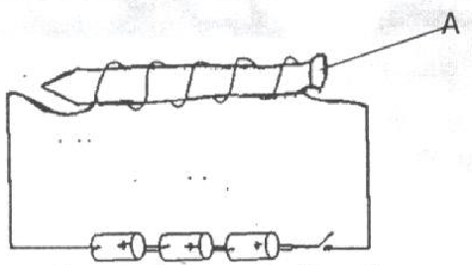

**50(a) Name the method of making a magnet shown ¡n the diagram.  
……………………………………………………………………………………………**

**(b) What pole will the part marked A become?  
……………………………………………………………………………………………**

**(C) What would you do to the dry cells in order to increase the strength of the magnet?  
……………………………………………………………………………………………**

**(d) Apart from the method shown in the diagram, name any other method of making a magnet.  
……………………………………………………………………………………………**

**5 1(a) Mention two primary sex changes that happen in boys.  
……………………………………………………………………………………………**

**……………………………………………………………………………………………**

**(b) Give two secondary sex changes which happen in both boys and girls.  
……………………………………………………………………………………………**

**……………………………………………………………………………………………**

**52(a) Name the two types of pollination in flowering plants.  
……………………………………………………………………………………………**

**……………………………………………………………………………………………**

**(b) Write any two agents of pollination.**

**……………………………………………………………………………………………**

**……………………………………………………………………………………………**

**The diagram below is oía human skin. Use it to answer question 53.**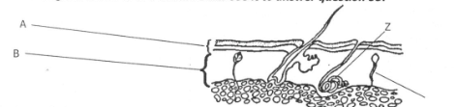

**53a)Name the layers A and B.  
……………………………………………………………………………………………**

**……………………………………………………………………………………………**

**b)Give the function of the parts labelledY and Z.  
……………………………………………………………………………………………**

**54. Match the diseases in list A with the signs and symptoms in list 8.**

**A B**

**Polio Swollen neck**

**Measles Stiffness of muscle**

**Tetanus Paralysed tissues**

**Diphtheria Skin rash**

**(a) Polio   
……………………………………………………………………………………………**

**(b) Measles   
……………………………………………………………………………………………**

**(c) Tetanus   
……………………………………………………………………………………………**

**(d) Diptheria   
……………………………………………………………………………………………**

**55. Study the diagram of the human ear below and use ¡t to answer the questions tl7at follow**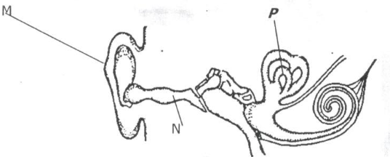

**a) Name the parts marked M and N.**

**……………………………………………………………………………………………**

**(b) Give the function of the part marked P  
……………………………………………………………………………………………**

**(c) Use letter B to show the part of the ear responsible for balancing the body.  
END**

**ITEM TWELVE**

**SECTION A**

**1. Besides claws, name any one other weapon used by animals for defence.  
……………………………………………………………………………………………**

**2. State any one way a slug is similar to a grass hopper.  
……………………………………………………………………………………………**

**3. Why is it necessary to groom finger nails?  
……………………………………………………………………………………………**

**4. What first aid can you give to someone with a broken humerus?  
……………………………………………………………………………………………**

**5. Apart from keeping water in the soil, in which other way is mulching important to a farmer?  
……………………………………………………………………………………………**

**6. Common salt gives flavor to food, give one other use of salt in the body.  
……………………………………………………………………………………………**

**7. Using an arrow indicate the direction of flow of electricity in the diagram.**

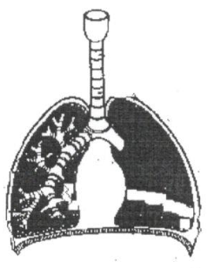 **……………………………………………………………………………………………**

**8. Why does smoke from a burning heap of grass move upwards?  
……………………………………………………………………………………………**

**9. State one method you would use to control insect pests.  
……………………………………………………………………………………………**

**10. Give one breed of rabbits.  
……………………………………………………………………………………………**

**11. Why is water not good for putting out petrol fire?  
……………………………………………………………………………………………**

**12. Why is a wheelbarrow classified as a second class lever?  
……………………………………………………………………………………………**

**13. Give one useful piece of information that should be considered before taking any drug.  
……………………………………………………………………………………………**

**14. Name any one raw material needed by green plants to make food.  
……………………………………………………………………………………………**

**15. What is dairy farming?  
……………………………………………………………………………………………**

**……………………………………………………………………………………………**

**16. Identify one root crop which is propagated by planting seeds.  
……………………………………………………………………………………………**

**17. Why does a potted plant grow towards the window?  
……………………………………………………………………………………………**

**18. Give one way of preventing constipation in children.  
……………………………………………………………………………………………**

**19. State one natural disaster common in mountainous areas.  
……………………………………………………………………………………………**

**20. Why are electric wires left sagging loosely between poles during construction?  
……………………………………………………………………………………………**

**21. Why do maize plants develop prop roots at maturity?  
……………………………………………………………………………………………**

**22. How is humus formed?  
……………………………………………………………………………………………**

**23. The diagram below shows a common garden tool. What is the use of this tool to a farmer?**

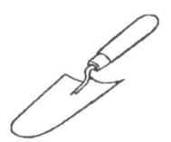 **……………………………………………………………………………………………**

**24. How does draining stagnant water control the spread of malaria?  
……………………………………………………………………………………………**

**25. Why does a car tyre wear out quickly from a tarmac road than on a murram road?  
……………………………………………………………………………………………**

**26. State the role of the eye as a sense organ in the body.  
……………………………………………………………………………………………**

**27. How is sisal important as a resource?  
……………………………………………………………………………………………**

**28. How do coniferous plants reproduce?  
……………………………………………………………………………………………**

**29. Of what importance are ventilators on a house?  
……………………………………………………………………………………………**

**30. Why can’t mushrooms make their own food?  
……………………………………………………………………………………………**

**31. State any one condition for rusting to take place.  
……………………………………………………………………………………………**

**32. Give any one sustainable way of using resources in the environment.  
……………………………………………………………………………………………**

**33. Name any one crop which is first grown as seedlings in a nursery bed.  
……………………………………………………………………………………………**

**34. Give any one common sign of a common cold.  
……………………………………………………………………………………………**

**35. Name the only flying mammal in the environment.  
……………………………………………………………………………………………**

**36. Where does fertilization take place in human beings?  
……………………………………………………………………………………………**

**37. How important is an embryo in a viable seed?  
……………………………………………………………………………………………**

**38. State any one habit that keeps your body clean.  
……………………………………………………………………………………………**

**39. Write any one material that dissolves in water.  
……………………………………………………………………………………………**

**40. Name the first stage in a village food path.  
……………………………………………………………………………………………**

**SECTION B.**

**41. (a) Name any two insects that sting their enemies.  
……………………………………………………………………………………………**

**(b) Why do the above named insects sting their enemies?  
……………………………………………………………………………………………**

**(c) State one difference between a scorpion and a preying mantis.  
……………………………………………………………………………………………**

**42. (a) What is thinning?  
……………………………………………………………………………………………**

**……………………………………………………………………………………………**

**(b) Give any two advantages of thinning.  
……………………………………………………………………………………………**

**……………………………………………………………………………………………**

**(c) Why are the leaves of a plant considered to be the most important past?  
……………………………………………………………………………………………**

**43. The diagram below is a musical instrument. Study it and answer question 43.**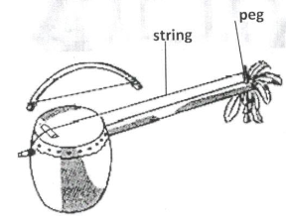

**(a) To which group of musical instruments does the above belong?  
……………………………………………………………………………………………**

**(b) How does it produce sound?  
……………………………………………………………………………………………**

**(c) What can be done to change the pitch of the above instrument?  
……………………………………………………………………………………………**

**(d) Give any one way of storing the sound produced by the above instrument.  
……………………………………………………………………………………………**

**44. (a) Name any two respiratory organs.  
……………………………………………………………………………………………**

**(b) How are the air sacs able to perform their function of gaseous exchange?  
……………………………………………………………………………………………**

**(c) Where in the human body does internal respiration take place?  
……………………………………………………………………………………………**

**45. (a) Give any two properties of pure water.  
……………………………………………………………………………………………**

**……………………………………………………………………………………………**

**(b) Why is distilled water not recommended for drinking?  
……………………………………………………………………………………………**

**……………………………………………………………………………………………**

**(c) Name one method used to produce clean water from dirty water.  
……………………………………………………………………………………………**

**……………………………………………………………………………………………**

**46. (a) What is a human skeleton?  
……………………………………………………………………………………………**

**……………………………………………………………………………………………**

**(b) In which way are muscles useful to the muscular skeletal system?  
……………………………………………………………………………………………**

**……………………………………………………………………………………………**

**(C) Give any two ways of caring for the muscular skeletal system.  
……………………………………………………………………………………………**

**……………………………………………………………………………………………**

**47. In four short sentences, describe how you would separate a mixture of salt, sand and iron filings.  
……………………………………………………………………………………………**

**……………………………………………………………………………………………**

**……………………………………………………………………………………………**

**……………………………………………………………………………………………**

**48. (a) What is a balanced diet?  
……………………………………………………………………………………………**

**……………………………………………………………………………………………**

**(b) Give any two major components of a balanced diet.  
……………………………………………………………………………………………**

**……………………………………………………………………………………………**

**(c) Give any one importance of water to the human body.  
……………………………………………………………………………………………**

**49. Below is a list of different groups of simple machines.**

**(a) How are they applied in our daily life?**

**(i) Pulleys  
……………………………………………………………………………………………**

**(ii) Wedges  
……………………………………………………………………………………………**

**(iii) Wheel and axles.  
……………………………………………………………………………………………**

**(b) Why is it easier to drop a load from a lorry than lifting it back to the lorry?  
……………………………………………………………………………………………**

**……………………………………………………………………………………………**

**50. (a) Write PHC in full.  
……………………………………………………………………………………………**

**(b) Which element of PHC helps in the control of the following;**

**(i) Rapid population growth  
……………………………………………………………………………………………**

**(ii) Drug abuse and addiction  
……………………………………………………………………………………………**

**(c) State any one principle of PHC.  
……………………………………………………………………………………………**

**51. (a) Why do builders construct houses with a damp proof course?  
……………………………………………………………………………………………**

**……………………………………………………………………………………………**

**(b) How dangerous is it to have a latrine near a water source?  
……………………………………………………………………………………………**

**(c) Give the use of the following components of a residential house.  
……………………………………………………………………………………………**

**(i) Windows  
……………………………………………………………………………………………**

**(ii) Ventilators  
……………………………………………………………………………………………**

**52. Match the items in list A with those in B.**

**A B**

**Oviduct absorption**

**Ileum diffusion**

**Cortex fertilization**

**Alvaeoli filtration**

**1. Oviduct  
……………………………………………………………………………………………**

**2. Strip cup  
……………………………………………………………………………………………**

**3. Cortex  
……………………………………………………………………………………………**

**4. Alveoli  
……………………………………………………………………………………………**

**53. (a) What is mulching?  
……………………………………………………………………………………………**

**……………………………………………………………………………………………**

**(b) Name any one material used for mulching.  
……………………………………………………………………………………………**

**(c) Write down one advantage and disadvantage of mulching.**

**(i) Advantage  
……………………………………………………………………………………………**

**……………………………………………………………………………………………**

**(ii) Disadvantage  
……………………………………………………………………………………………**

**……………………………………………………………………………………………**

**54. (a) What protozoa causes malaria?  
……………………………………………………………………………………………**

**(b) Where do female mosquitoes lay their eggs?  
……………………………………………………………………………………………**

**(c) Give any two ways or controlling the spread of malaria fever.  
……………………………………………………………………………………………**

**……………………………………………………………………………………………**

**55. The diagram below shows three rays of light on a mirror.**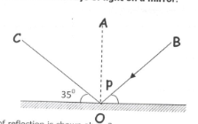

**(a) . What kind of reflection is shown above?  
……………………………………………………………………………………………**

**(b) Name ray BO.  
……………………………………………………………………………………………**

**(c) Put an arrow head correctly on ray CO.**

**(d) What is the size of angle P in degrees?  
……………………………………………………………………………………………**

**END**

**ITEM THIRTEEN**

**SECTION A**

**1. Name the part of the human body which protects the brain.  
……………………………………………………………………………………………**

**2. Why should granaries be kept dry?  
……………………………………………………………………………………………**

**3. How are leguminous crops useful in a crop rotation cycle?  
……………………………………………………………………………………………**

**4. In which one way can the sun be useful in germ control?  
……………………………………………………………………………………………**

**5. Why do birds need beaks?  
……………………………………………………………………………………………**

**The diagram below shows a beehive. Use it to answer question 6 and 7.**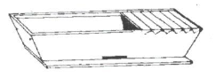

**6. Identify the type of bee hive shown above.  
……………………………………………………………………………………………**

**7. Give one advantage of using the above hive.  
……………………………………………………………………………………………**

**8. Give the importance of correct body posture to humans.  
……………………………………………………………………………………………**

**9. Why is rinsing necessary when washing clothes?  
……………………………………………………………………………………………**

**10. Besides getting manure, how else do farmers benefit from cow dung and urine?  
……………………………………………………………………………………………**

**11. Write, any one unit used when buying food stuffs for home use.  
……………………………………………………………………………………………**

**The diagram below shows a locally made tool for washing hands. Use it to answer questions 12 and 13.**

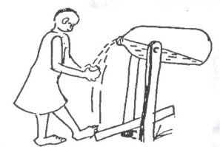

**12. Identify the sanitary tool shown above.  
……………………………………………………………………………………………**

**13. By use of letter M, show the effort.  
……………………………………………………………………………………………**

**14. Give any one advantage of row planting in crop growing.  
……………………………………………………………………………………………**

**15. Which method of preparing hides involves the use of the sun’s energy?  
……………………………………………………………………………………………**

**16. Write one danger of drying wet wood/timber under sunshine.  
……………………………………………………………………………………………**

**The diagram below shows food being prepared. Use it to answer question 17 and 18**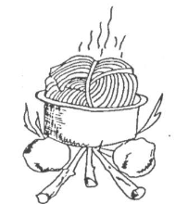

**17. Give the Importance of covering the food with banana leaves as shown above.  
……………………………………………………………………………………………**

**18. In which one way are algae similar to pine?  
……………………………………………………………………………………………**

**19. Name any one funous we eat.**

**……………………………………………………………………………………………**

**20. I-low does smoking help to preserve meat?  
……………………………………………………………………………………………**

**21. Which component of the environment helps to increase oxygen into the atmosphere?  
……………………………………………………………………………………………**

**22. How does paint prevent rusting iii metals?  
……………………………………………………………………………………………**

**23. Give one way in which water promotes personal hygiene?  
……………………………………………………………………………………………**

**24. How can you stop small fire in a school building?  
……………………………………………………………………………………………**

**25. Why is a ship able to float on water?  
……………………………………………………………………………………………**

**26. Name the second stage in the life cycle of a butterfly.  
……………………………………………………………………………………………**

**27. Why is it not good to rub the eyes when an object drops on them?  
……………………………………………………………………………………………**

**28. Name any one human disease that can spread when a sick person coughs or sneezes without covering his/her mouth.  
……………………………………………………………………………………………**

**29. How does a fuse work?  
……………………………………………………………………………………………**

**30. Why are magnets unable to attract pieces of wood?  
……………………………………………………………………………………………**

**31. In the space below, draw the shape of a dairy cow.  
……………………………………………………………………………………………**

**32, Name one mineral energy resource.  
……………………………………………………………………………………………**

**33. Why is flowering of plants grouped under biological changes?  
……………………………………………………………………………………………**

**34. Give any one advantage of rotational grazing in cattle management.  
……………………………………………………………………………………………**

**35. Why is poor disposal of broken bottles dangerous to humans?  
……………………………………………………………………………………………**

**36. How do trees help in rain formation?  
……………………………………………………………………………………………**

**The diagram below shows a soya bean seed. Use it to answer question 37 and 38.**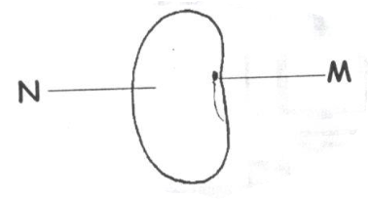

**37. Name part labeled M.  
……………………………………………………………………………………………**

**38. How is part N useful to the seed?  
……………………………………………………………………………………………**

**39. Why is sub soil not good for crop growing?  
……………………………………………………………………………………………**

**40. Give the use of a shade on a nursery bed.  
……………………………………………………………………………………………**

**SECTION B**

**41. (a) Name any one crop pest that attacks maize grains in store.  
……………………………………………………………………………………………**

**(b) Write one danger of storage pests to crop farmers?  
……………………………………………………………………………………………**

**(c) Give any two ways storage pests can be controlled.  
……………………………………………………………………………………………**

**42. Match the animals in A to their habitats in B correctly.**

**A B**

**(i) white ants web**

**(ii) spider byre**

**(iii)goat ant hill**

**(iv)cow pen**

**(iv) White ants  
……………………………………………………………………………………………**

**(y) Spider  
……………………………………………………………………………………………**

**(vi) Goat  
……………………………………………………………………………………………**

**(vii) Cow  
……………………………………………………………………………………………**

**43. (a) What are convulsions?**

**……………………………………………………………………………………………**

**……………………………………………………………………………………………**

**(b) Give the cause of convulsion.  
……………………………………………………………………………………………**

**(c) Give the first aid for convulsions.  
……………………………………………………………………………………………**

**(d) Flow can convulsions be controlled?  
……………………………………………………………………………………………**

**44.(a) Besides running water, name one other agent of seed dispersal.  
……………………………………………………………………………………………**

**(b) Outline two characteristics of seeds dispersed by running water.  
……………………………………………………………………………………………**

**(c) Name any one plant dispersed by running water.  
……………………………………………………………………………………………**

**45. Study the table below and complete it.**

|  |  |  |
| --- | --- | --- |
| **Vaccine** | **When given** | **Site of immunisation** |
| **Measles vaccine** | **6, 10 & 14 weeks** | **……………………………** |
| **BCG** | **…………………………….** | **Right upper arm** |
| **…………………………….** | **Birth** | **Mouth** |

**46. The diagram below shows a source of electricity use it to answer question 46**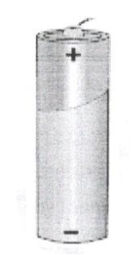

**a) Name the source of electricity shown above.  
……………………………………………………………………………………………**

**b) By use of letter N, show the negative terminal.  
……………………………………………………………………………………………**

**c)State the energy change that takes place in the above source of electricity.  
……………………………………………………………………………………………**

**d) Write one disadvantage of using the above source of electricity.  
……………………………………………………………………………………………**

**47 a) Give any two natural causes of changes in the environment.  
……………………………………………………………………………………………**

**……………………………………………………………………………………………**

**b) Write two activities that a child can do to prevent drought.  
……………………………………………………………………………………………**

**……………………………………………………………………………………………**

**48.a) Give any two enemies of bees.  
……………………………………………………………………………………………**

**b) How do people protect their hives from bee enemies?  
……………………………………………………………………………………………**

**49 a) What is excretion ?  
……………………………………………………………………………………………**

**b) Mention any two examples of excretory organs.  
……………………………………………………………………………………………**

**c) How do we care for our excretory organs?  
……………………………………………………………………………………………**

**50. The diagram below shows the human foot. Use it to answer question.**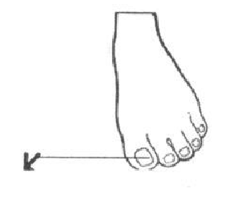

**a) Identify the part marked K.  
……………………………………………………………………………………………**

**b)Name one tool used in shortening structure K.  
……………………………………………………………………………………………**

**c)Write one fungal disease that affects the human foot.  
……………………………………………………………………………………………**

**d)How do you care for the above body part?  
……………………………………………………………………………………………**

**51. The diagram below shows a model of the human arm. Use it to answer questions that follow.**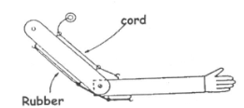

**i). What do the following parts represent in our bodies;**

**a). Cord  
……………………………………………………………………………………………**

**b). Rubber  
……………………………………………………………………………………………**

**ii). Name any one bone found in part X,  
……………………………………………………………………………………………**

**ii). By use of letter S, show the position of the hinge joint.  
……………………………………………………………………………………………**

**52. (a) Why do animals need homes?  
……………………………………………………………………………………………**

**(b) How are wild animals kept in a game reserve cared for by people?  
……………………………………………………………………………………………**

**53. (a) Name any two groups of simple machines.  
……………………………………………………………………………………………**

**(b) How can you improve on the proper functioning of simple machines?  
……………………………………………………………………………………………**

**54. The diagram below shows a rabbit. Use it to answer questions that follow.**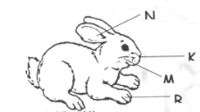

**(a) Name the part labeled R añd K.  
……………………………………………………………………………………………**

**(b) How is the function of part K different from that of N?  
……………………………………………………………………………………………**

**(c) How do we care for the above animal?  
……………………………………………………………………………………………**

**55. (a) Name any two intestinal worms ¡n humans.  
……………………………………………………………………………………………**

**……………………………………………………………………………………………**

**(b) Write any one sign of worm infestation in humans.  
……………………………………………………………………………………………**

**(c) How can you prevent yourself from intestinal worms?  
……………………………………………………………………………………………**

**END**

**,**

**ITEM FOURTEEN**

**SECTION A.**

**1. Mention one condition plants need to make starch.  
……………………………………………………………………………………………**

**2. Why are telephone wires left loose between poles.  
……………………………………………………………………………………………**

**3. What is the importance of family planning n a family?  
……………………………………………………………………………………………**

**4. Give one breed of chicken.  
……………………………………………………………………………………………**

**5. How does a drum produce Sound when hit?  
……………………………………………………………………………………………**

**6. How are sweets dangerous to our teeth?  
……………………………………………………………………………………………**

**7. In which state of matter is water at 109°C?  
……………………………………………………………………………………………**

**8. Name the type of tooth shown in the diagram below.**

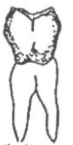 **……………………………………………………………………………………………**

**9. Name the intestinal diarrhoeal disease caused by amoeba.  
……………………………………………………………………………………………**

**10. What is the importance f ossicles in the ear?  
……………………………………………………………………………………………**

**11. Why is heat necessary in a broader?  
……………………………………………………………………………………………**

**12. What are pathogens?  
……………………………………………………………………………………………**

**13, Aprt from silent heat, name another type of heat in cattle keeping.  
……………………………………………………………………………………………**

**14. Which polio vaccine is administered to babies at birth?  
……………………………………………………………………………………………**

**15. Give one natural process in plants which uses oxygen.  
……………………………………………………………………………………………**

**16. How do amphibians like frogs help in controlling malaria?  
……………………………………………………………………………………………**

**17. Write HIV in full.  
……………………………………………………………………………………………**

**18. The diagram below shows roots of some plants. Name the roots marked Q.**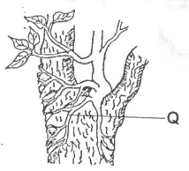

**19. Why don’t fraternal twins look alike in most cases?  
……………………………………………………………………………………………**

**20. Name the smallest unit of a living thing.  
……………………………………………………………………………………………**

**21. How can filtered water be made safe for drinking?  
……………………………………………………………………………………………**

**22. What is the use of a sickle to a farmer?  
……………………………………………………………………………………………**

**23, Which digestive disorder does one get due to lack of roughages in the diet?  
……………………………………………………………………………………………**

**24. Apart from the mode of spread, give any other similarity between trachoma and cholera.  
……………………………………………………………………………………………**

**25. Why are people suffering from severe vomiting given plenty of fluid to drink?  
……………………………………………………………………………………………**

**26. Besides fish, name any one animal that can be kept in an aquarium.  
……………………………………………………………………………………………**

**27. How are conifers different from ferns?  
……………………………………………………………………………………………**

**28. What advice would you give to a rabbit farmer whose rabbits are suffering from intestinal worms?  
……………………………………………………………………………………………**

**29. State one way of managing accidents.  
……………………………………………………………………………………………**

**30. Which vector spread zika germs?**

**……………………………………………………………………………………………**

**31. Farrowing is the act of giving birth to a litter in swine. Name the smallest young one in a litter.  
……………………………………………………………………………………………**

**32. Why isn’t an earthworm regarded as a soil component?  
……………………………………………………………………………………………**

**33. Which type of immunity does a man of 30 years gets after recovering from sickness without using any drug?  
……………………………………………………………………………………………**

**34. Name the valve of the left part of the heart that separates the atrium from ventricle.**

**……………………………………………………………………………………………**

**The diagram blow is a bottle of syrup a mother bought from a pharmacy. Use it to answer questions 35 and 36.**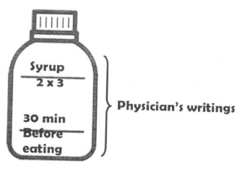

**35. What do we call the physician’s writings on the bottle above?  
……………………………………………………………………………………………**

**36. Point out any one danger that one might face if he/she does not follow physicians writings.  
……………………………………………………………………………………………**

**37. What are arthropods?  
……………………………………………………………………………………………**

**……………………………………………………………………………………………**

**38. Why is the eye said to be a sense organ?  
……………………………………………………………………………………………**

**39. What happens to pollen grains when they are deposited on the stigma?  
……………………………………………………………………………………………**

**40. Name any one example of primary colours of light.  
……………………………………………………………………………………………**

**SECTION B**

**41. Below are diagrams of blood vessels. Use them to answer the following questions.**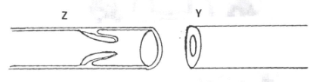

**(a) Name the type of blood vessels Y and Z  
……………………………………………………………………………………………**

**(b) Give one functional difference between blood vessel Y and Z.  
……………………………………………………………………………………………**

**(c) To which body system do blood vessels above belong?  
……………………………………………………………………………………………**

**42. (a) What is PHC?  
……………………………………………………………………………………………**

**……………………………………………………………………………………………**

**(b) State any two elements of PHC where a P.7 pupil can fully participate.  
……………………………………………………………………………………………**

**……………………………………………………………………………………………**

**(c) Give one role of VHT in a community.  
……………………………………………………………………………………………**

**43. (a) Write any two components of soil.  
……………………………………………………………………………………………**

**(b) State two processes in which soil is formed.**

**……………………………………………………………………………………………**

**44. The table below shows the development time for types of bees in a beehive. Use it to answer the questions that follow**

|  |  |  |  |
| --- | --- | --- | --- |
| **Stage** | **Worker** | **Queen** | **Drone** |
| **Hatching** | **3 days** | **3 days** | **3 days** |
| **Cell covering** | **8 days** | **8 days** | **10 days** |
| **Turns into pupa** | **11 days** | **10 days** | **14 days** |
| **Becomes an adult** | **20 days** | **15 days** | **22 days** |
| **Comes out of the cell** | **21 days** | **16 days** | **24 days** |

**(a) What event takes place at the same time to all the three types of bees in the hive?  
……………………………………………………………………………………………**

**(b) Which type of bee matures fastest?  
……………………………………………………………………………………………**

**(c) At what stage in the life cycle are bees on the 5 day?  
……………………………………………………………………………………………**

**(d) After how many days will the worker bee be able to fly?  
……………………………………………………………………………………………**

**45. Match the following lists correctly.**

**A B**

**Biological change digestion**

**Atmospheric change formation of clouds**

**Chemical change ecdysis**

**Physical change sublimation**

**4. Biological change ………………………………………………………………………**

**5. Atmospheric change …………………………………………………………………..**

**6. Chemical change ………………………………………………………………………**

**7. Physical change ………………………………………………………………………..**

**46. (a) What type of skeleton do the following organisms posses?**

**(e) Snail   
……………………………………………………………………………………………**

**(f) Newt  
……………………………………………………………………………………………**

**(b) Name the example of immovable joint in the human skeleton.  
……………………………………………………………………………………………**

**(c) How is the human skeleton important to circulatory system?  
……………………………………………………………………………………………**

**47. (a) What is a beam in light energy?  
……………………………………………………………………………………………**

**……………………………………………………………………………………………**

**(b) List down two types of beams.  
……………………………………………………………………………………………**

**……………………………………………………………………………………………**

**(c) What happens when light rays strikes on an opaque object?  
……………………………………………………………………………………………**

**……………………………………………………………………………………………**

**48. (a) Three liquids paraffin, mercury and water were put in a test tube and shaken. Then they were allowed to settle as shown below.**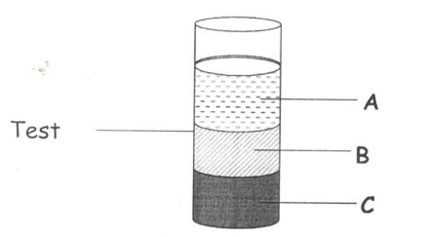

**(i) Name the liquid marked B and C.  
……………………………………………………………………………………………**

**(ii) Why does liquid A settle on top?  
……………………………………………………………………………………………**

**(iii) Why does liquid C behave like that in the diagram above?  
……………………………………………………………………………………………**

**49. Bamwiine weighs 6okgs and sits 6 metres away from the pivot on a see-saw. How heavy shouldAtamba who is sitting 4 metres away from the pivot be in order to balance the see-saw.**

**50. (a) What are resources?  
……………………………………………………………………………………………**

**……………………………………………………………………………………………**

**(b) Name two non-living resources.  
……………………………………………………………………………………………**

**……………………………………………………………………………………………**

**(c) Give one type of resource n the environment.  
……………………………………………………………………………………………**

**51. (a) Name the best food for babies.  
……………………………………………………………………………………………**

**(b) Why is it not advised for the mothers with breast cancer to breast feed their newly born babies?  
……………………………………………………………………………………………**

**(c) State the malnutritional disease that develops due to lack of the following food values in the diet:**

**(i)Proteins  
……………………………………………………………………………………………**

**(ii)Carbohydrates  
……………………………………………………………………………………………**

**52. (a) Complete the food chain using arrows**

**Bacteria fowl locust plant leaves**

**Fowl locust plant leaves**

**(b Identify the following organisms from the above food chain**

**(i) Producer   
……………………………………………………………………………………………**

**(ii) secondary consumer   
……………………………………………………………………………………………**

**(c) Name the source of energy for the plant leaves to make their food.  
……………………………………………………………………………………………**

**53. (a) Name any one type of latrine.  
……………………………………………………………………………………………**

**(b) How far should a pit latrine be from a water source?  
……………………………………………………………………………………………**

**(c) Give the function of a screen on a VIP latrine.  
……………………………………………………………………………………………**

**(iv) Point out the type of latrine commonly used in rural areas of Uganda.  
……………………………………………………………………………………………**

**54. (a) What is germination?  
……………………………………………………………………………………………**

**……………………………………………………………………………………………**

**(b) Name one type of germination.  
……………………………………………………………………………………………**

**(c) What condition of germination is got from the sun?  
……………………………………………………………………………………………**

**(d) Mow is oxygen useful during germination?  
……………………………………………………………………………………………**

**55. The diagram below is the respiratory system.**

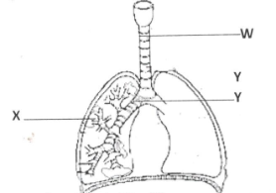**X**

**i) Name the parts marked Y and X.  
……………………………………………………………………………………………**

**ii) Why is part W made up of rings of cartilage?  
……………………………………………………………………………………………**

**iii) How is part X adopted to its functioning?  
……………………………………………………………………………………………**

**END**

**ITEM FIFTEEN**

**SECTION A (40 MARKSÇ)**

**1. Name any one cause of soil erosion.  
……………………………………………………………………………………………**

**2. State one way of controlling endo parasites in cattle.  
……………………………………………………………………………………………**

**3. Give any one human activity that can result into environmental degradation.  
……………………………………………………………………………………………**

**4. Which immunisable disease causes stiffness of muscles?  
……………………………………………………………………………………………**

**5. How does a mushroom differ from a conifer as far as feeding is concerned?  
……………………………………………………………………………………………**

**6. Name any one device that changes mechanical energy into electric energy.  
……………………………………………………………………………………………**

**The diagram below shows a freely suspended magnet. Use it to answer the questions 7 and 8.**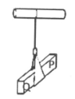

**7. Name the pole of the above magnet marked with letter Q.  
……………………………………………………………………………………………**

**8. How is the property of magnet shown above useful to pilots?  
……………………………………………………………………………………………**

**9. The diagram below is of an electric bulb. Give a reason why part A is coiled.**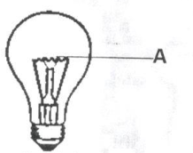

**10. Name the plant process that helps in cooling the plants.  
……………………………………………………………………………………………**

**11. How is water useful to a germinating bean seed?  
……………………………………………………………………………………………**

**12. Name any one mineral deficiency disease.  
……………………………………………………………………………………………**

**13. State one way of maintaining proper functioning of the heart.  
……………………………………………………………………………………………**

**14. Which type of change maintains the properties of the original substance?  
……………………………………………………………………………………………**

**15. In which chamber of a modern bee hive does a queen bee lay its eggs?  
……………………………………………………………………………………………**

**16. Why does a child suffering from tape worms become malnourished?  
……………………………………………………………………………………………**

**17. In which way does the cutting of finger nails short control the spread of diarrheal diseases?  
……………………………………………………………………………………………**

**18. How does the use of a charcoal saving stoves help to conserve the environment?  
……………………………………………………………………………………………**

**19. Name one living natural source of light.  
……………………………………………………………………………………………**

**20. The diagram below shows a lever system used to raise a load. On which part of the lever marked C and P would one use more effort to lift the load.**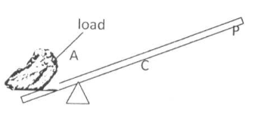

**21. Why is water not good for putting out fire caused by Petrol?  
……………………………………………………………………………………………**

**22. Name the type of energy possessed by a bird resting on a branch of a tree.**

**……………………………………………………………………………………………**

**23. How does the practice of crop rotation control pests in the garden?  
……………………………………………………………………………………………**

**24. Name the mineral salt that helps in the formation of blood.  
……………………………………………………………………………………………**

**25. Which habit in pregnant women leads to produce under weight babies?  
……………………………………………………………………………………………**

**26. Write any one way in which seeds are useful to people.  
……………………………………………………………………………………………**

**27. Which sexual transmitted disease can cause blindness in young babies?  
……………………………………………………………………………………………**

**28. Identify the form of energy that can pass through wood without destroying it.  
……………………………………………………………………………………………**

**29. Musa’s child was found to be dehydrated. Mention any one possible cause of dehydration.  
……………………………………………………………………………………………**

**30. Mention any one disorder of digestive system.  
……………………………………………………………………………………………**

**31. How does smoke move from fire move through the chimney?  
……………………………………………………………………………………………**

**32. What is the use of a switch in an electric circuit?  
……………………………………………………………………………………………**

**33. How is a scald different from a burn as used in accidents and first aid?  
……………………………………………………………………………………………**

**34. What scientific term do we give to the degree of coldness or hotness of a place or an object?  
……………………………………………………………………………………………**

**35. Give one reason why movement is essential to living things.  
……………………………………………………………………………………………**

**36. How is demography important to the government?  
……………………………………………………………………………………………**

**37. Identity one component of the living environment.  
……………………………………………………………………………………………**

**38. What is the importance of a strip cup on livestock farm?  
……………………………………………………………………………………………**

**39. Mention any one way school children can control dumping of rubbish in the school compound.  
……………………………………………………………………………………………**

**40. State the component of air used by plants to make plant proteins.  
……………………………………………………………………………………………**

**SECTIOON B.**

**41. (a) Name any one practice that promotes oral health.  
……………………………………………………………………………………………**

**(b) State any one adaptation of the molar teeth for their function during digestion.  
……………………………………………………………………………………………**

**(c) Which region of a tooth appears above the gum?  
……………………………………………………………………………………………**

**(d) Give any one disease of the teeth.  
……………………………………………………………………………………………**

**42. Kato weighs 72kgs and sits 6m away from the fulcrum on a seesaw. His sister Nyangorna who weighs 36kg sits on the opposite side of the seesaw and they balance.**

**(i) Draw a sketch to show the positions of Kato and his sister Nyangoma on the see saw.**

**……………………………………………………………………………………………**

**(ii) How far is Nyangoma from Kato?  
……………………………………………………………………………………………**

**43. Match the insects in group A with their respective larva in group B.**

**A B**

**Butterfly grub**

**Bees Nymph**

**Mosquito caterpillar**

**Cockroach wriggler.**

**(e) Butterfly ………………………………………………………………………………**

**(f) Bees . ………………………………………………………………………………….**

**(g) Mosquito ……………………………………………………………………………..**

**(h) Cockroach …………………………………………………………………………….**

**44. In which way are the following parts important in the human muscular skeleton system?**

**(i) Ligament ……………………………………………………………………………….**

**(ii) Cartilage ………………………………………………………………………………**

**(b Name any two lona bones found in the human lea.**

**……………………………………………………………………………………………**

**45. The diagram below shows one of the optical instruments. Use it to answer the questions that follow.**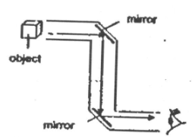

**(a) Name the above optical instrument.  
……………………………………………………………………………………………**

**(b) Name the type of mirrors used in the above instrument.  
……………………………………………………………………………………………**

**(c) State the use of the mirrors in the instrument.  
……………………………………………………………………………………………**

**(d) How is the above instrument useful to submarine soldiers?  
……………………………………………………………………………………………**

**46. (a) Name any one enzyme found in;**

**(i) Gastric juice …………………………………………………………………………..**

**(ii) Pancreatic juice ……………………………………………………………………….**

**(b) Which acid is used to kill germs taken in with food in the stomach?  
……………………………………………………………………………………………**

**(c) Name the class of food first digested in the stomach.  
……………………………………………………………………………………………**

**47. The diagram below shows different seeds in our environment.**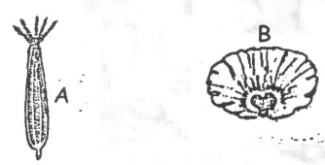

**(a) State the way the above seeds are dispersed in our environment.  
A…………………………………………………………………………………………**

**B…………………………………………………………………………………………**

**(b) State any two importance of seed dispersal to plants.  
……………………………………………………………………………………………**

**48. (a) Give the meaning of the following terms as used in sound.**

**1. Pitch   
……………………………………………………………………………………………**

**2. Volume   
……………………………………………………………………………………………**

**3. Noise   
……………………………………………………………………………………………**

**(b) How do we call’ musical instruments that produce Sound when hit?  
……………………………………………………………………………………………**

**49. (a) What is a biological change?  
……………………………………………………………………………………………**

**(b) Name any two biological changes in plants.  
……………………………………………………………………………………………**

**(c) How are biological changes similar to chemical changes?  
……………………………………………………………………………………………**

**50. (a) What is drug Prescriptions?  
……………………………………………………………………………………………**

**……………………………………………………………………………………………**

**(b) Give any two uses of drug prescription to a sick person.  
……………………………………………………………………………………………**

**……………………………………………………………………………………………**

**(c) Why should drugs be kept out of reach of young children?  
……………………………………………………………………………………………**

**……………………………………………………………………………………………**

**51. a) State any one way of making water safe for drinking.**

**……………………………………………………………………………………………**

**(b) Why is distilled water not recommended for drinking?  
……………………………………………………………………………………………**

**(c) Name any one immunisable disease spread through drinking contaminated water.  
……………………………………………………………………………………………**

**(d) Give any one way we care for water bodies.  
……………………………………………………………………………………………**

**52. (a) Name the garden tool used for the following:**

**(i) Leveling soil  
……………………………………………………………………………………………**

**(ii) Transplanting seedlings .  
……………………………………………………………………………………………**

**(b) State any one way of controlling rusting of our garden tools.  
……………………………………………………………………………………………**

**(c) Mention any one danger of rusting on garden tools.  
……………………………………………………………………………………………**

**53. The diagram below shows the model of breathing mechanisms of the lungs. lise it to answer the questions that follow.**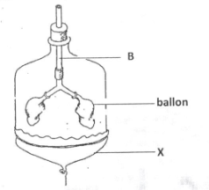

**(i) Which body system does the above diagram represent?  
……………………………………………………………………………………………**

**(ii) What do the following parts stand for?**

**(e) B  
……………………………………………………………………………………………**

**(f) X  
……………………………………………………………………………………………**

**(iii) Why is it not advisable for a person to breathe through the mouth?  
……………………………………………………………………………………………**

**54. (a) What are annual crops?  
……………………………………………………………………………………………**

**(b) Mention any two examples of annual crops.  
……………………………………………………………………………………………**

**(c) How does a scare crow control birds in the gardens?  
……………………………………………………………………………………………**

**55. Most dia rrhoeal diseases are spread through the 4F’s, write the 4Fs in their correct order.  
……………………………………………………………………………………………**

**……………………………………………………………………………………………**

**……………………………………………………………………………………………**

**……………………………………………………………………………………………**

**END**